**USER**

**MANUAL**

*Furnitures Shop Management System - User's Manual*

November 2017

**Revision Sheet**

|  |  |  |
| --- | --- | --- |
| **Release No.** | **Date** | **Revision Description** |
| Rev. 0 | 10/31/2017 | Initial Creation |
| Rev. 1 | 1/12/18 | Revision for Copyright |
|  |  |  |
|  |  |  |

Table of Contents

CHAPTER 1 | Introduction

The Furniture Shop offers wide range of products, through their furnitures, and services through deliveries. They utilize their business by manufacturing their own furnitures, and they also allow their customers to submit their own design for the business to produce, assuming that it is feasible. A 50% down payment must be collected for Pre-Orders before furnitures production, this can be paid through customer's bank account, this means that billing the remaining 50% is substantial for the transaction.

If an ordered furniture is not picked-up by the customer for certain time, the customer's 50% down payment will serve as storage fee, it will increase as time goes by. When the stored furniture reaches a certain time, it will be sold again as an on-hand furniture. Cancelling an order that is already under production also comes with a fee.

Customized products are evaluated first. If the management find it feasible, then they will calculate the materials to be used and the estimated price of the furniture, if not, then the management will send an email explaining the furniture rejection and suggestions to make it more feasible.

The Furniture Shop's transaction may be of common process, but its potential problems and issues can disrupt the whole transaction, making it complex.

Fortunately, technology can now be used alongside our businesses to make transactions easier, faster, and more reliable. Thus, the Furniture Shop Management System.

CHAPTER 2 | General Information

2.0 | System Overview

The Furniture Shop Management System covers some of the processes of the business. Its subsystems are: Order Management, Billing and Collection, and Production Tracking. Order Management allows the user to order products offered by the business, and at the same time orders by the customers are managed by the management. Billing in Collection is concerned about billing the customer his/her remaining balance, as well as collecting it. Production Tracking is in line with what production phase in which a furnitures is currently undergoing. These subsystems covers most of the business's transaction.

2.1 | System Requirements

The system needs the following hardware to fully function and personal computer that meets the following minimum standards:

In order for the system to fully function on a workstation/computer, the following minimum requirements must be attained:

2.1.1 | **Hardware Requirements**

|  |  |
| --- | --- |
| **Hardware Component** | **Specification** |
| Processor | 4 GHz, Intel Core i7 |
| Installed Memory (RAM) | 8.00GB or higher |
| Network | 5Mbps |
| Hard Disk Drive | 1TB or higher |
| Operating System | Windows 7 or higher |

2.1.2 | **Software Requirements**

|  |  |
| --- | --- |
| **Category** | **Specifications** |
| Operating System | Windows 7 or higher |
| Database | MySQL |
| Browser Compatibility | Google Chrome, Mozilla Firefox, Microsoft Edge, Mobile Browser |

2.2 | Installation

**Step 1** – Open a browser.

**Step 2** – Click the URL and search for **www.filipinianafurnitures.ph**

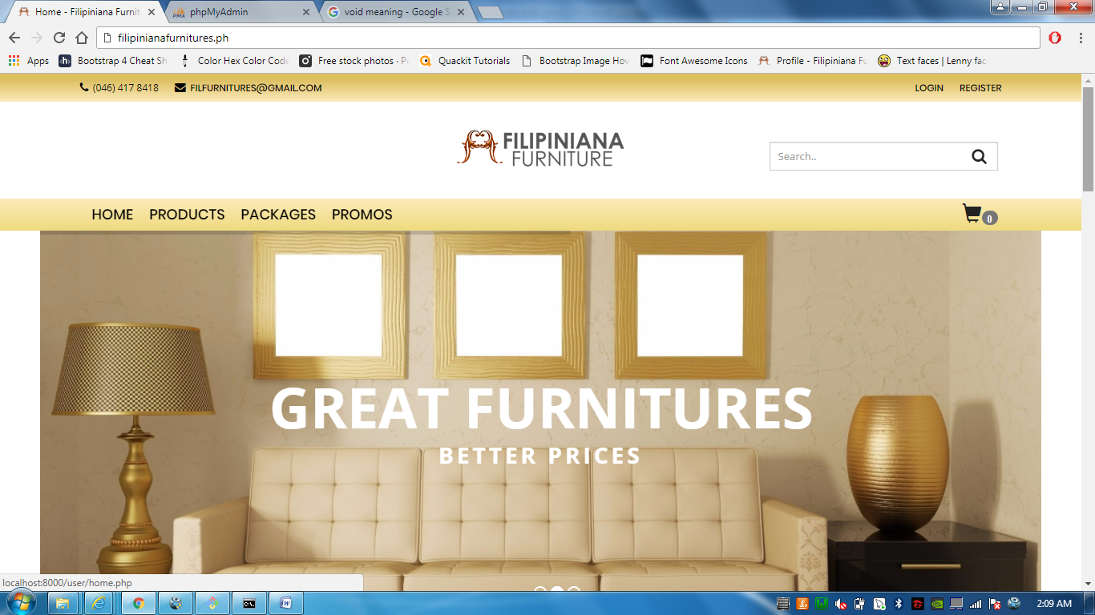

2.3 | Getting to know the System

2.3.1 | Homepage



Upon typing **www.filipinianafurnitures.ph,** you will be directed to this page.

2.3.2 | Dashboard

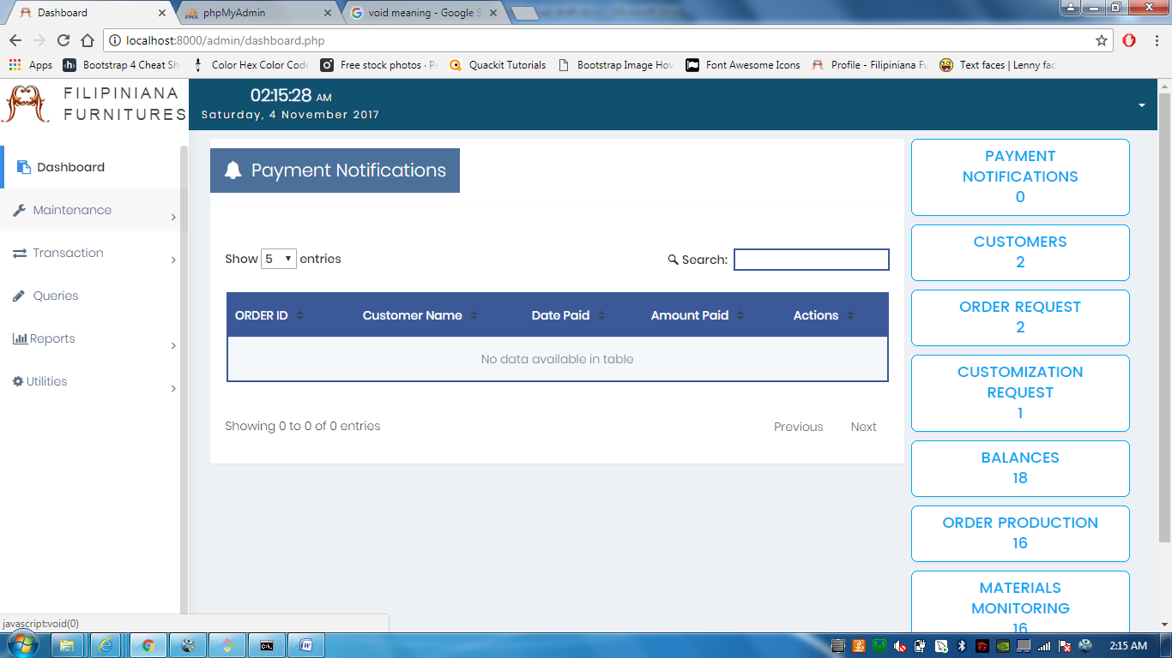

This is the Management dashboard, it contains most of the notifications in your business.

2.3.3 | Maintenance

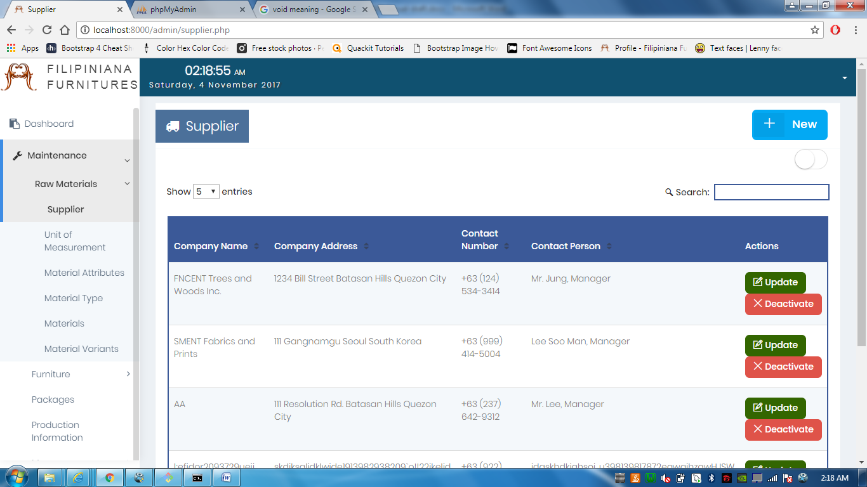

The **Supplier Maintenance** lets you put name where the raw materials came from.

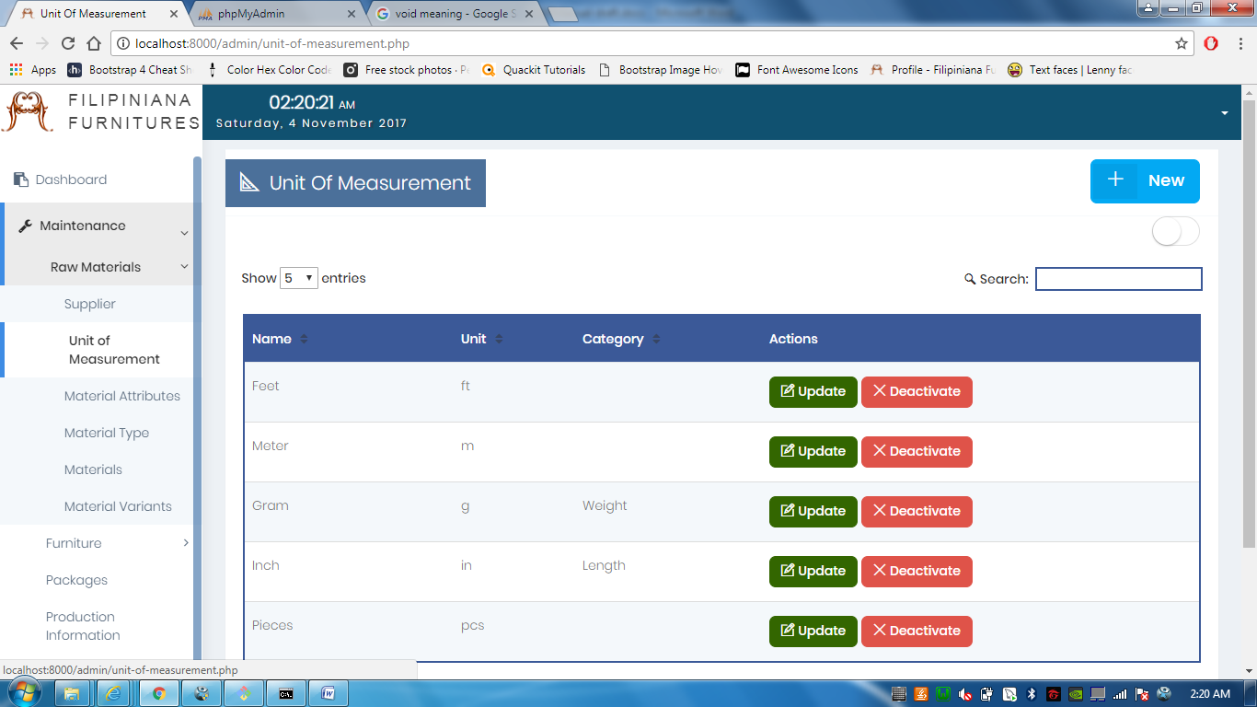

The **Unit of Measurement** **Maintenance** allows you to put measurements being used in the business.

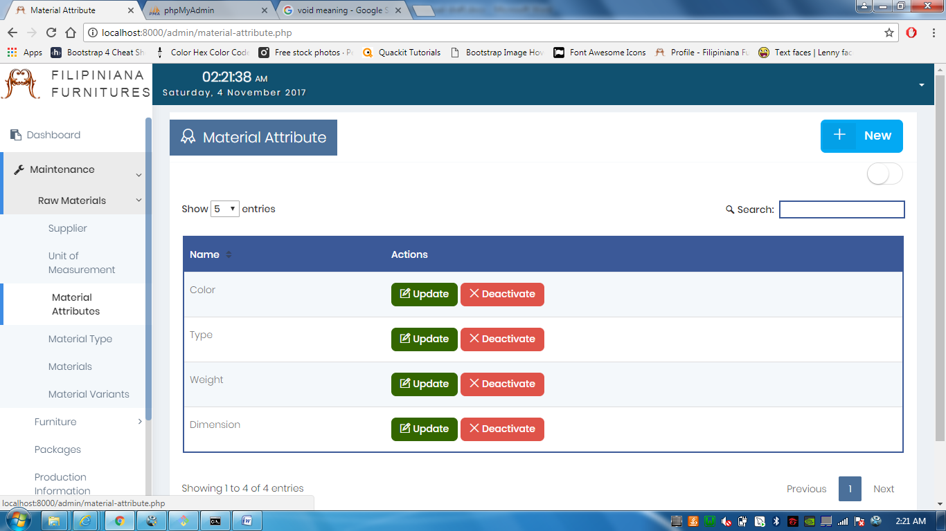

**Material Attributes Maintenance** allows you to add attributes to raw materials, you can also match it up to its possible unit of measurements.

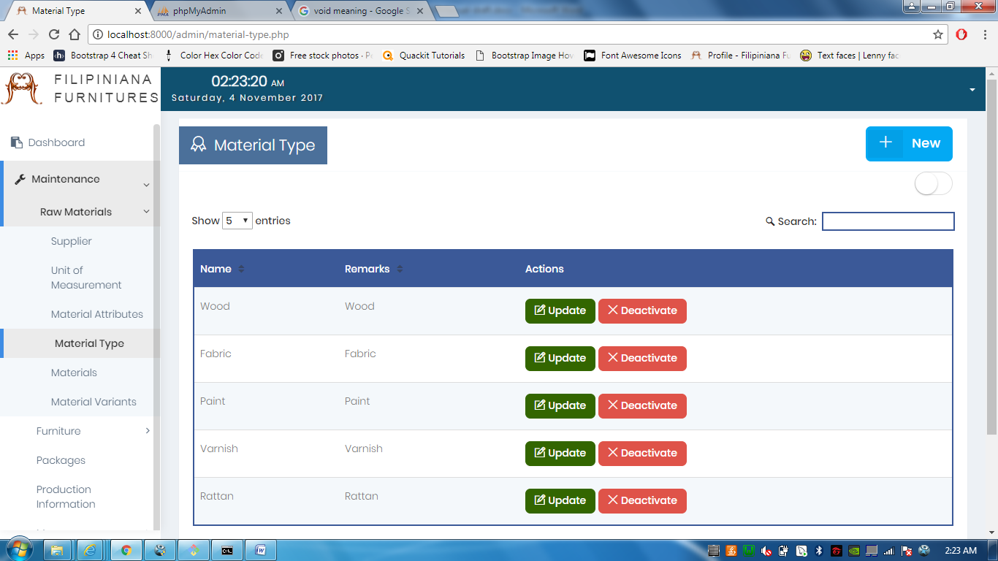

The **Material Type Maintenance** allows to add product types. It contains the general name of raw materials.

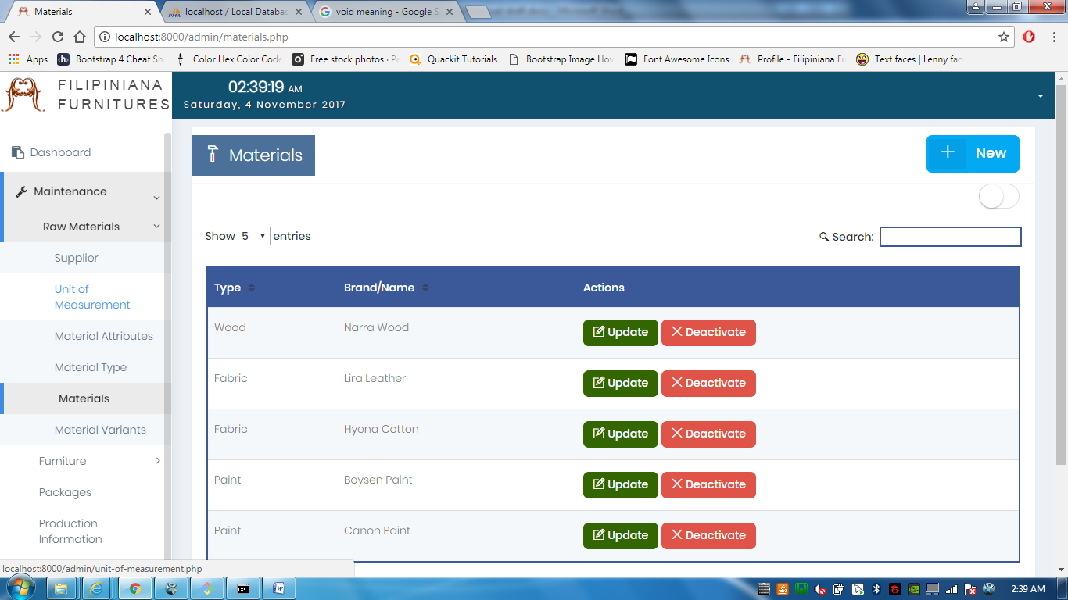

The **Material Maintenance** allows you to add materials and its brand.

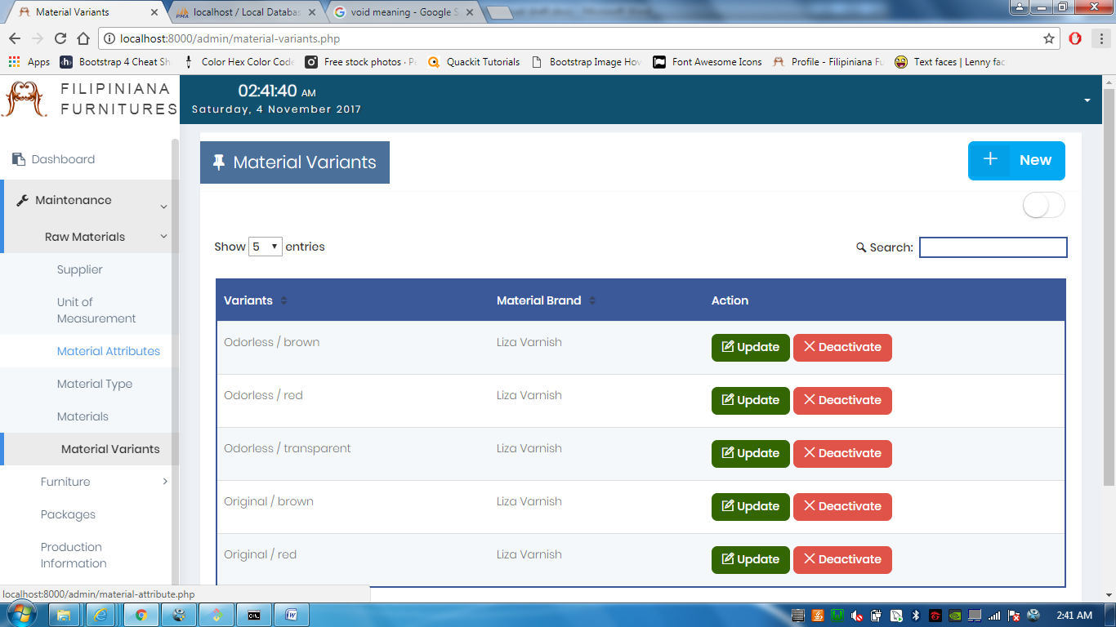

The **Material Variants Maintenance** is the most specific maintenance for raw materials. It allows you to denote a material along with its measurement, attributes, Brand, etc.

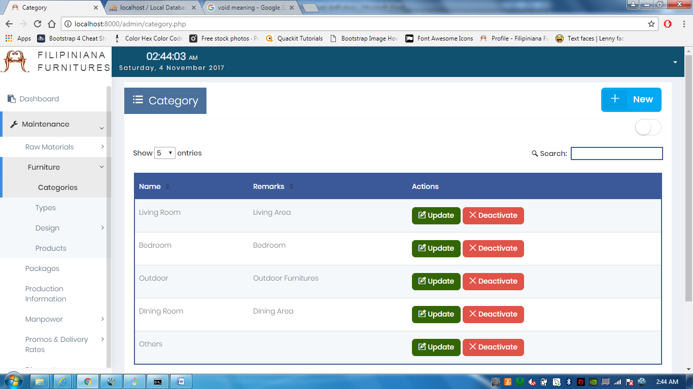

Under **Furniture Maintenance,** comes **Category Maintenance,** which allows you to denote categories furnitures would fall in, like Living Room and the like.

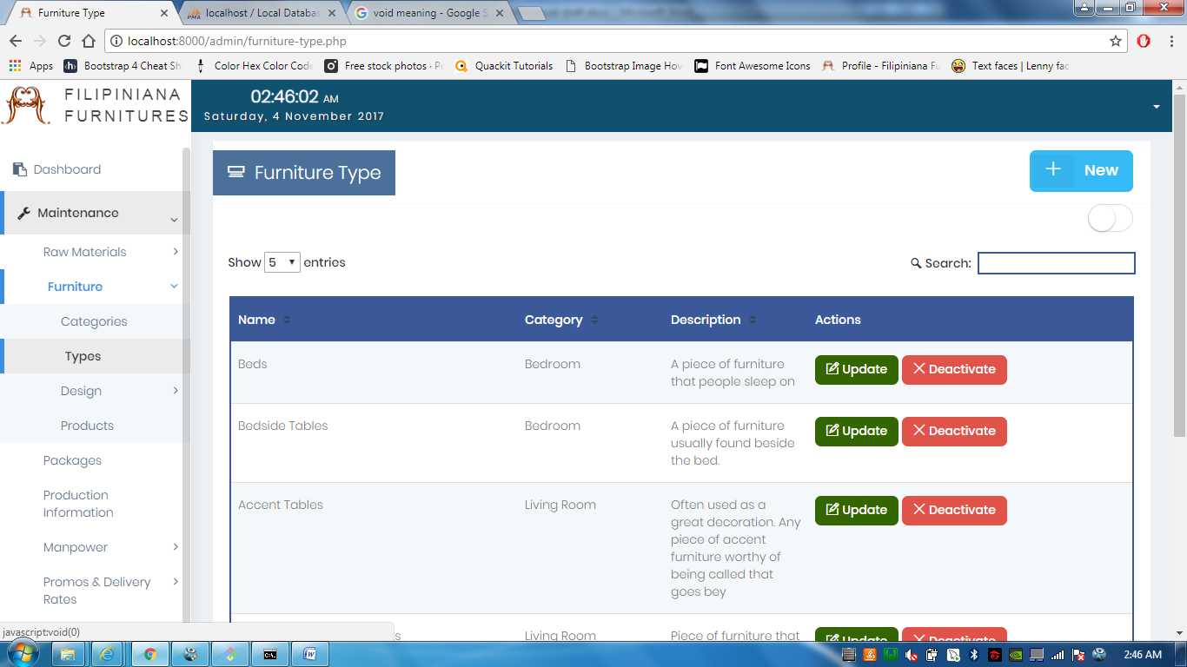

**Furniture Type** allows you to denote the type of furnitures being sold, in adding a new furnitures type, category is denoted alongside type for there are furnitures of the same type but different categories.

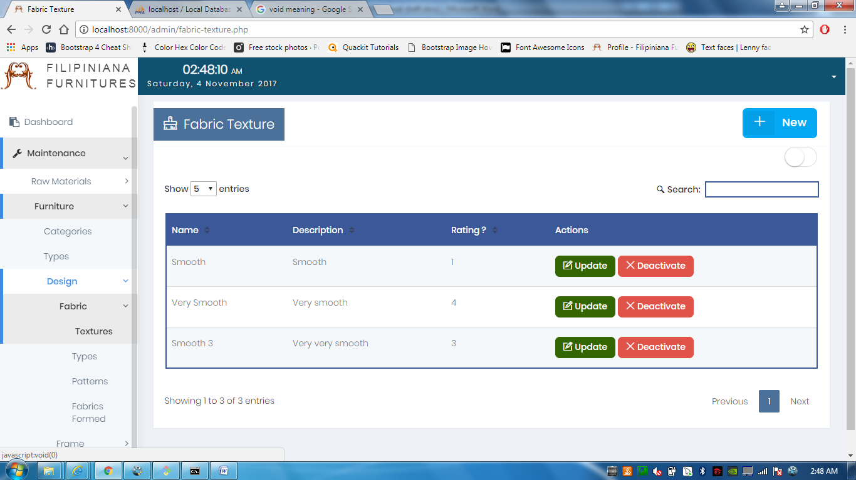

Under Furniture design, 2 sub-maintenance lies: Fabrics and Frameworks. Under Fabrics Maintenance, is the **Fabric Texture Maintenance**, which allows you to add a fabric texture and its numerical rating.

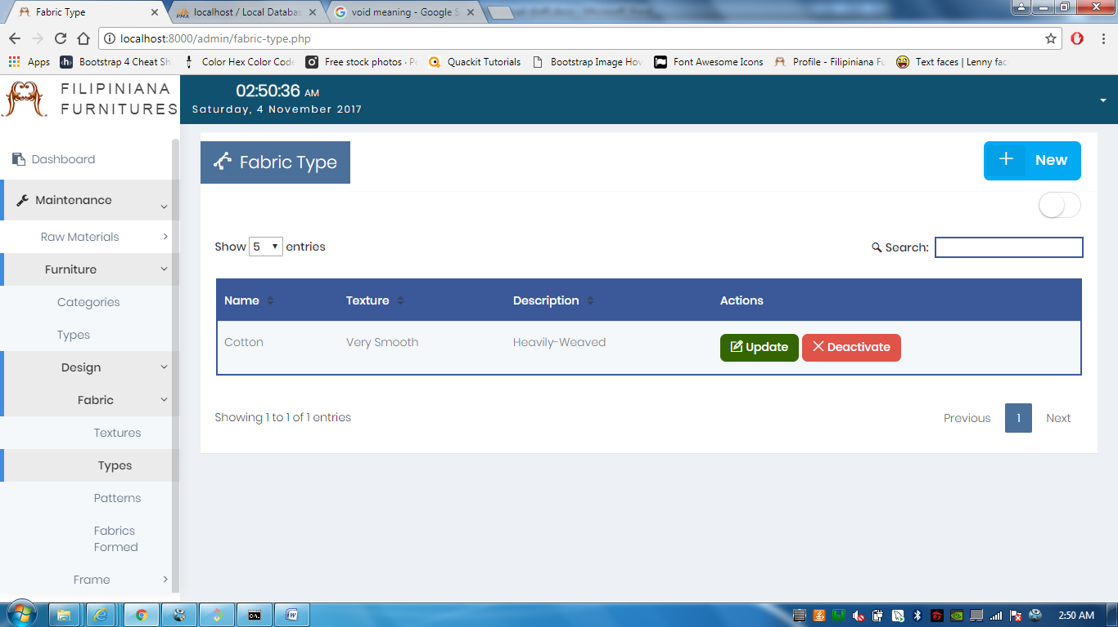

In **Fabric Type Maintenance**, you get the chance to denote a Fabric Type and match it with its texture.

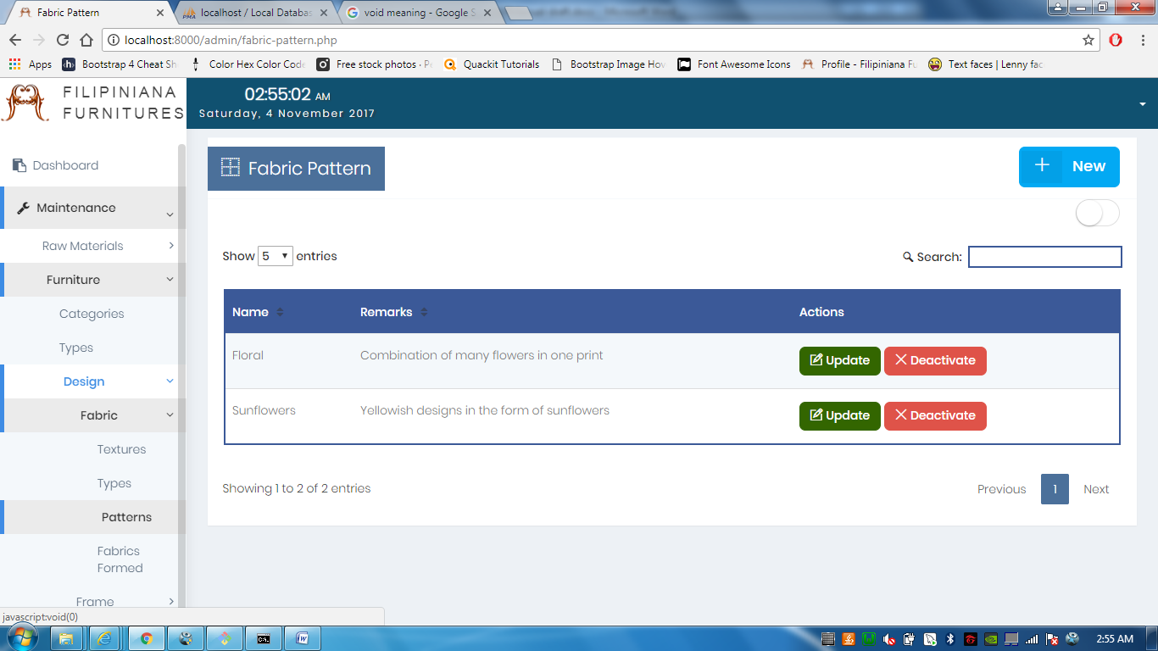

In **Fabric Pattern Maintenance,** the manager can add the patterns his/her business has to offer.

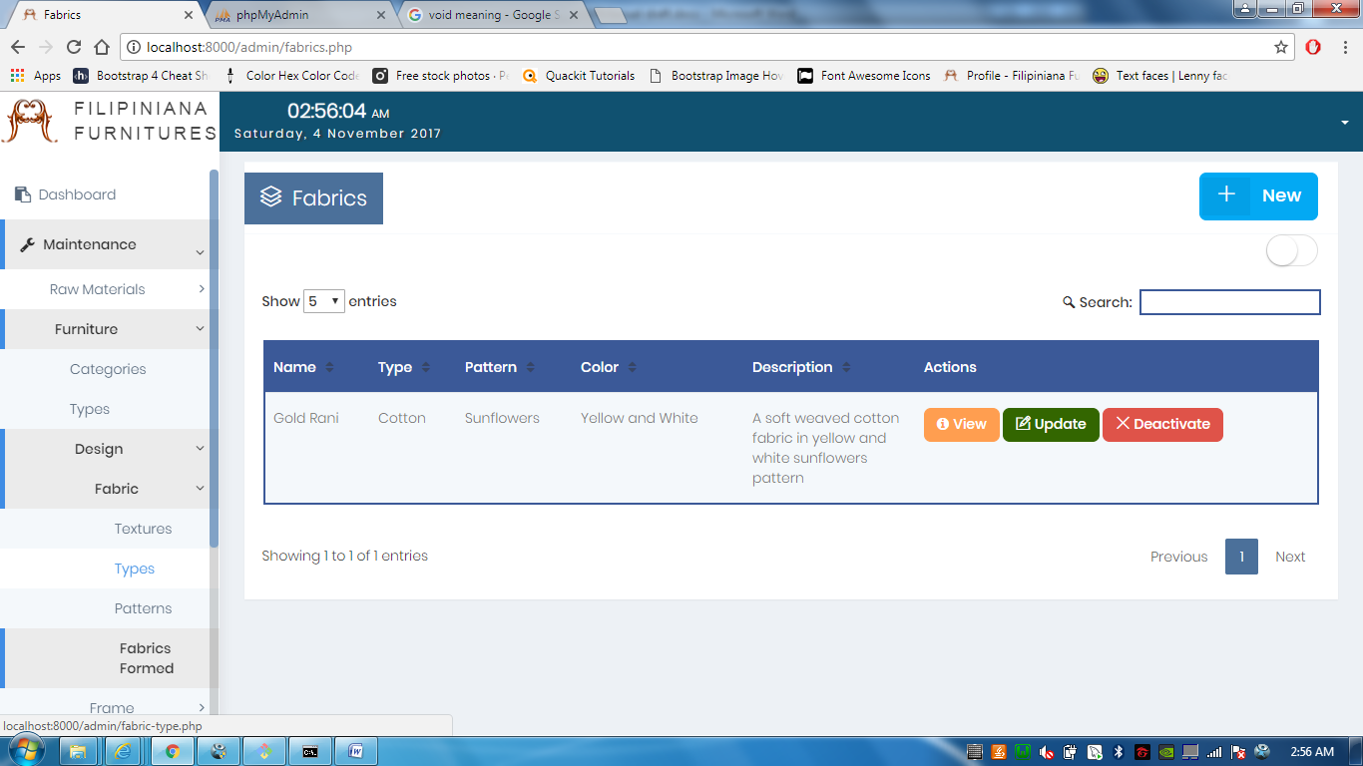

In **Fabrics Formed Maintenance**, you can denote the fabrics, this includes the texture, type, and pattern, that can be used in upholstered furnitures

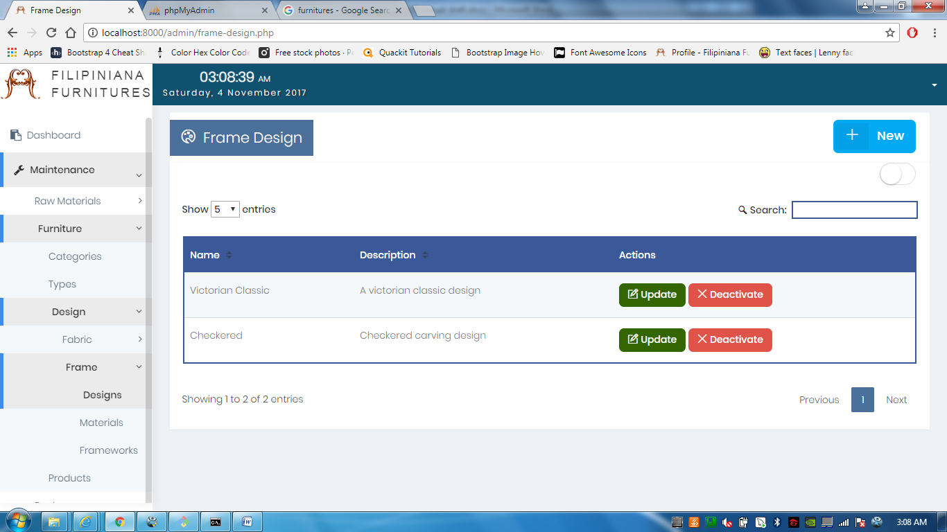

Now under Frame, is **Design Maintenance,** denotes the framework designs offered by the management.

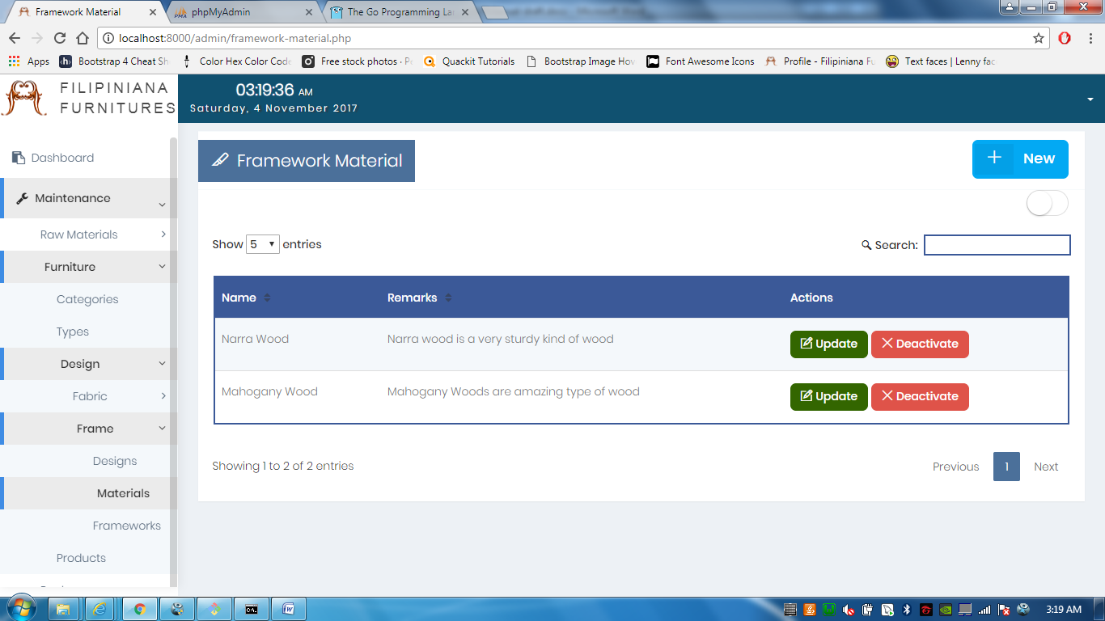

In **Materials Maintenance**, it denoted what possible type of material is used in the framework, it can be steel, Mahogany, Narra, or anything that is offered by the business.

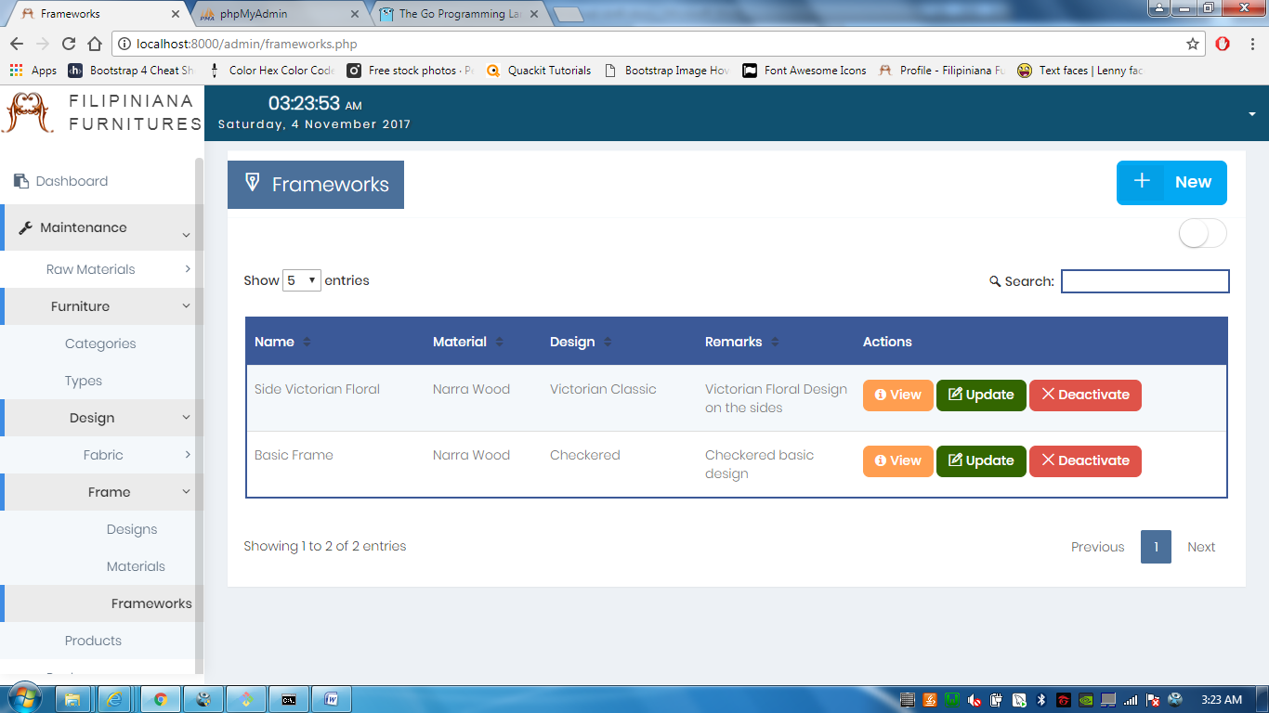

The **Frameworks Maintenance**, allows you to add the frameworks that can be used to create furnitures. This is a combination of design and material into the framework.

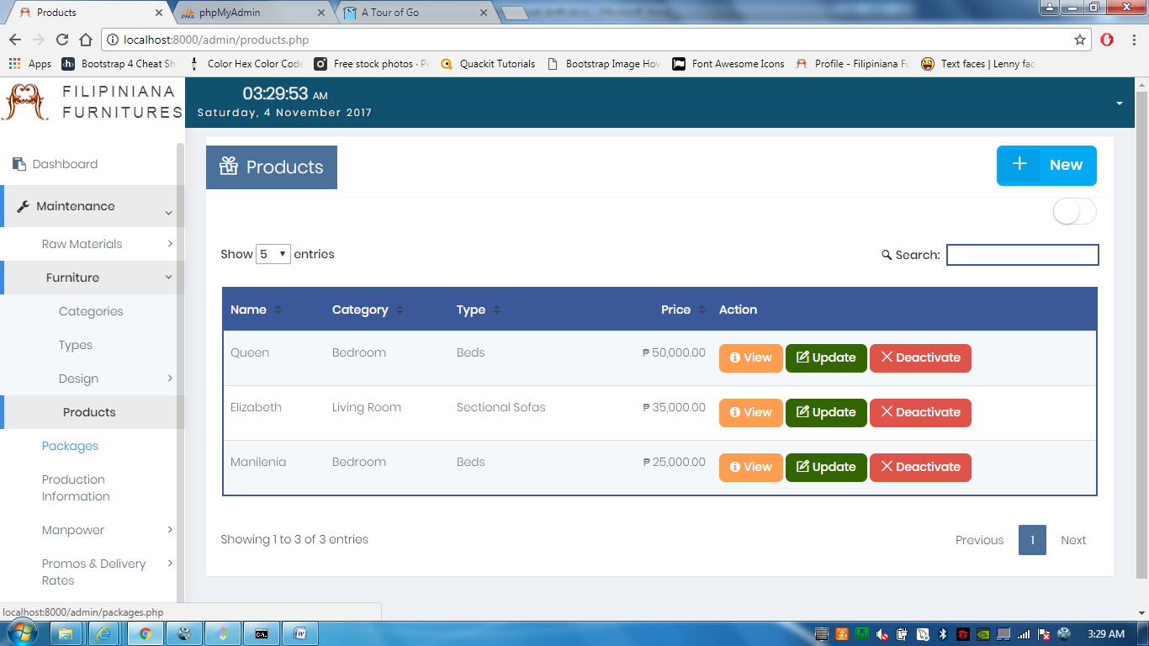

In **Products Maintenance**, is where you denote the products that are being sold by the management. By default, the products in this maintenance are for Pre-Order only.

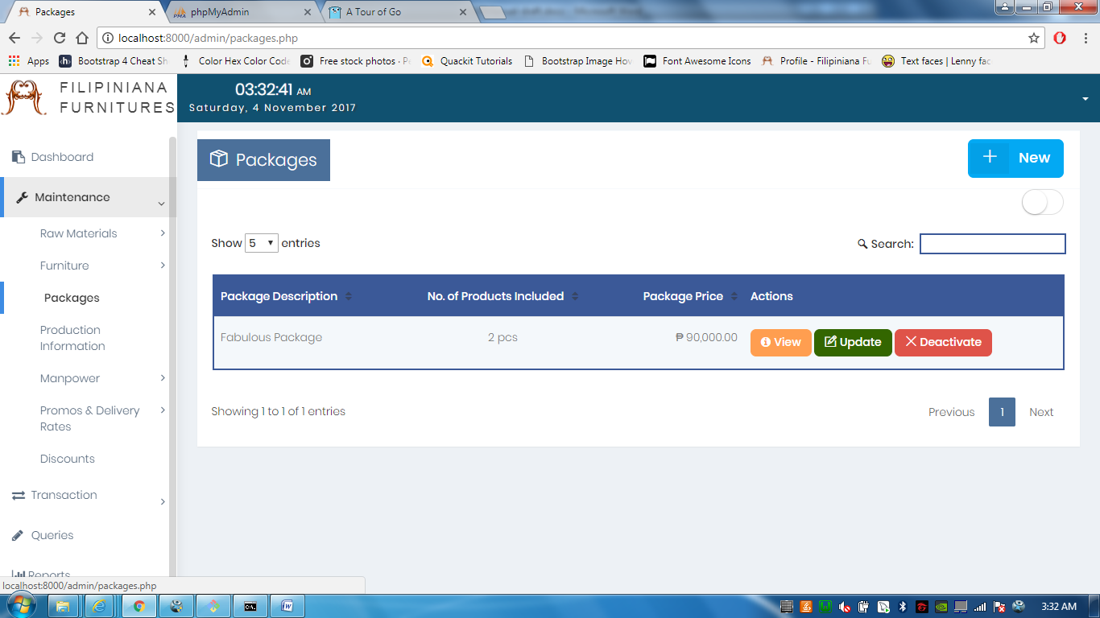

**Package Maintenance**, this is where you can see the packages that are offered by the business.

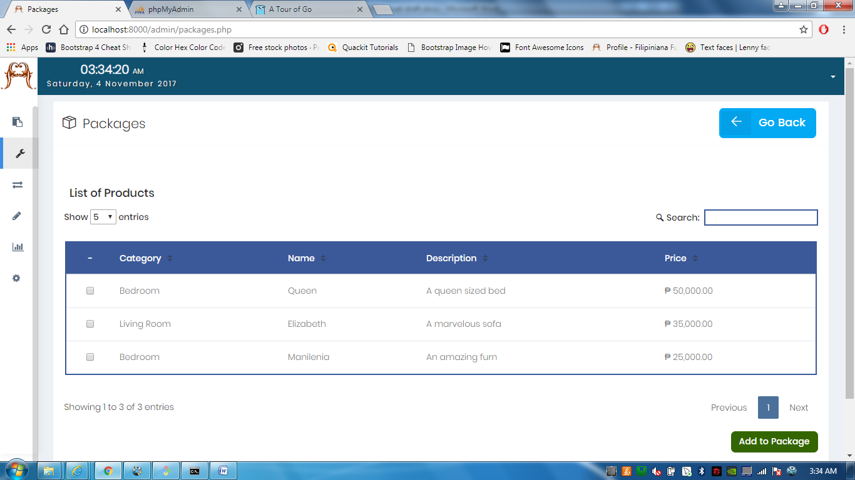

In the **Package Maintenance**, if you click the **+New** button, you are directed to this page, this is where you can select the products that are to be included in the package.

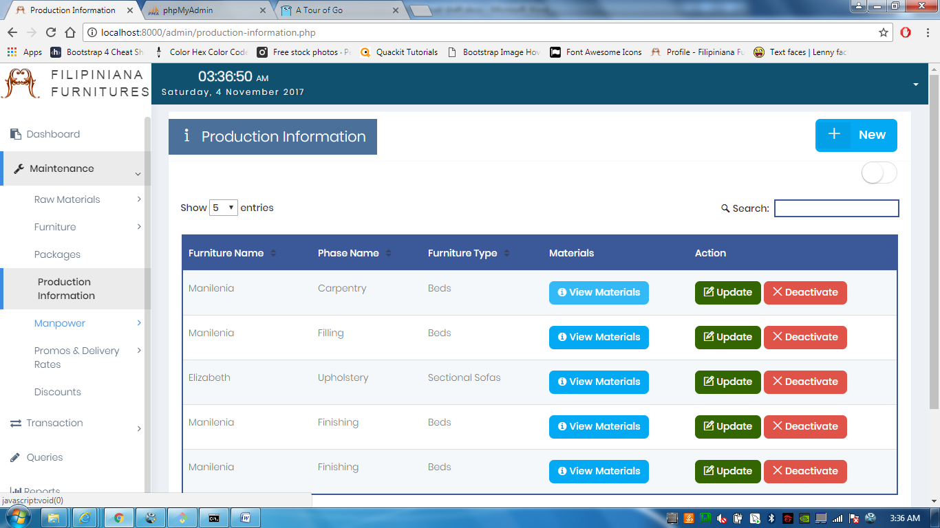

The **Production Information** is essential in production tracking. This is where how one furniture is made, the materials to be used & the production phases it should undergo.

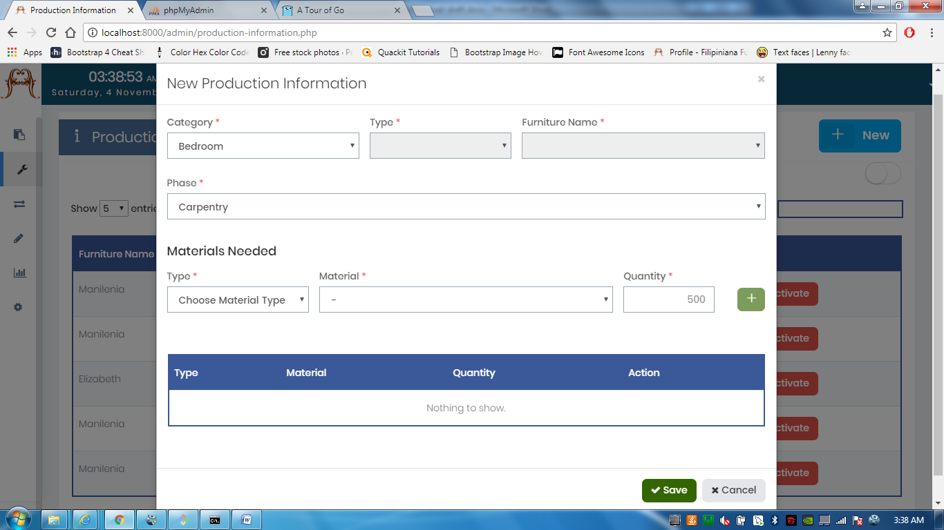

While in **Production Information**, if you click **+New,** a modal (like in the image above) pops up, you denote the furniture, one of the production phases it can undergo, and all the materials needed for that phase (In this case, materials needed for carpentry only. Not the whole production).

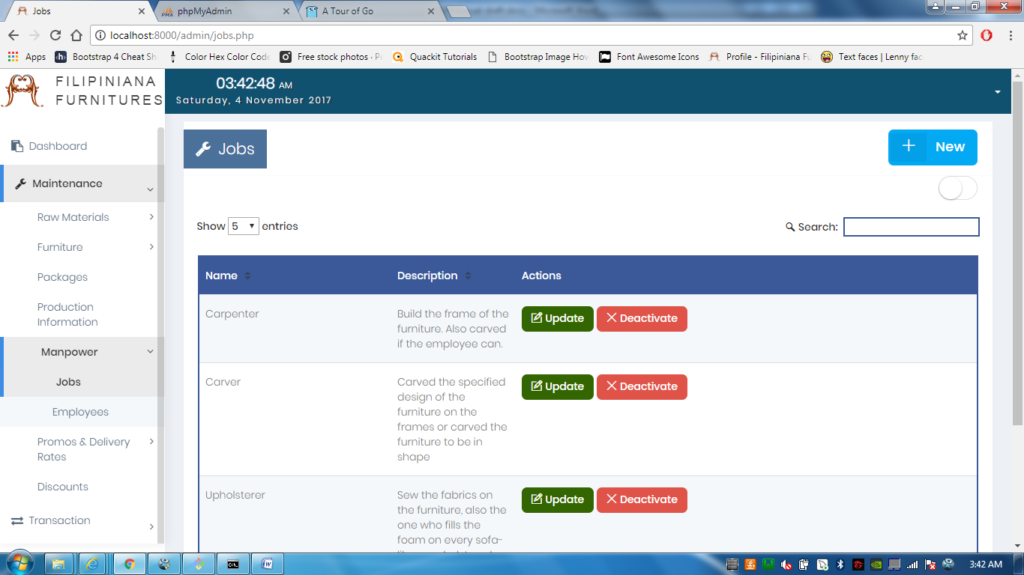

Under **Manpower**, **Job Maintenance** lets you add jobs that are currently in the business.

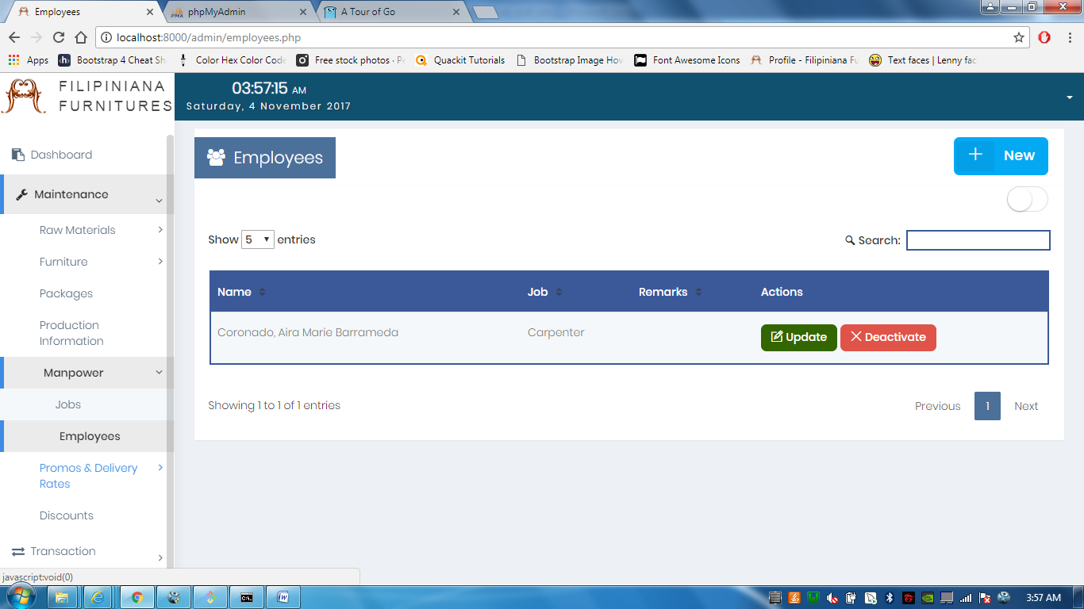

The **Employees Maintenance**, lets you list down all employees of the branch. This is also used for reference in delegation on Production Tracking.

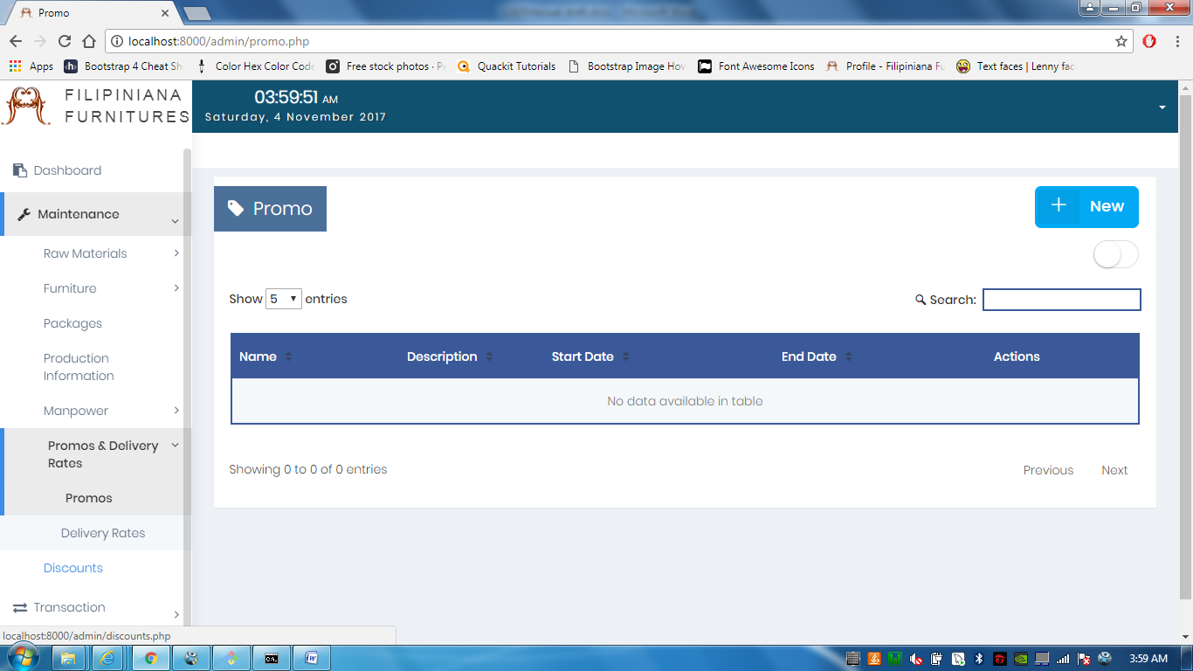

Under Promos & Delivery Rates is the **Promo Maintenance**, which allows you to manage promos; make one it active or deactivate an active one.

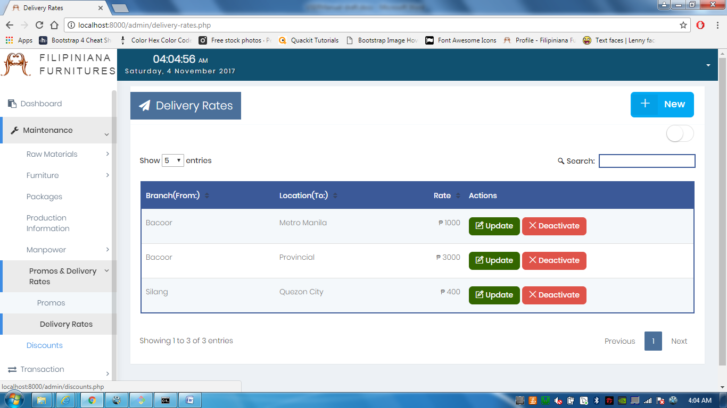

The **Delivery Rates Maintenance** lets you manage delivery rates, having the branch as the initial location.

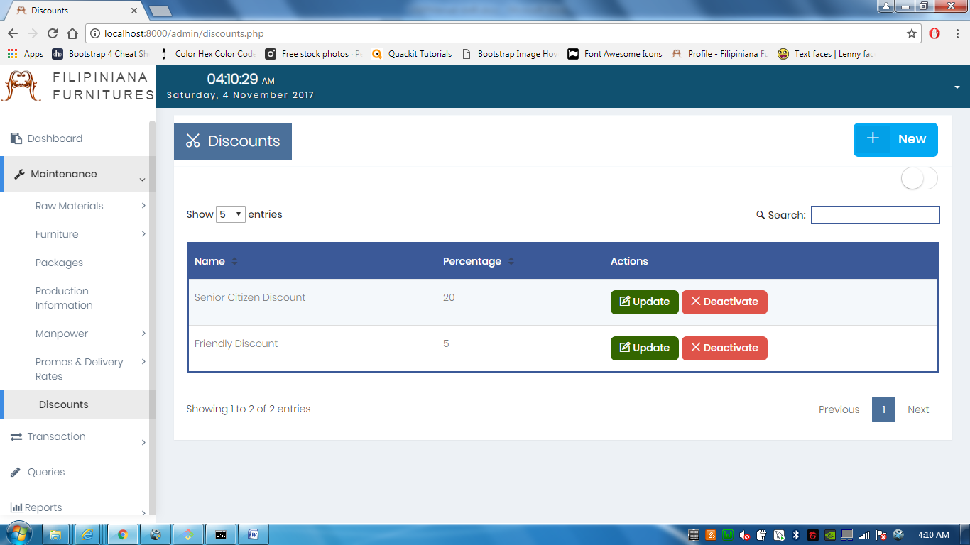

Lastly, the **Discount Maintenance**, which allows you to list all discounts the business offers.

2.3.4 | Transaction

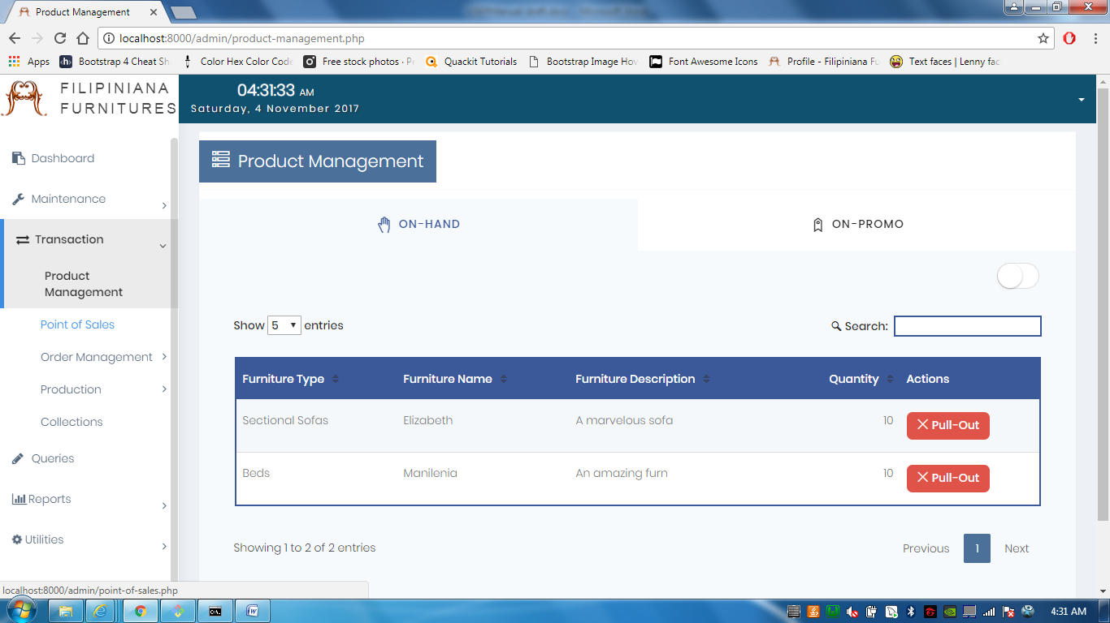

**Product Management** manages on-hand products, **x Pull-out** is used if an on hand is to be pulled-out for repair or order.

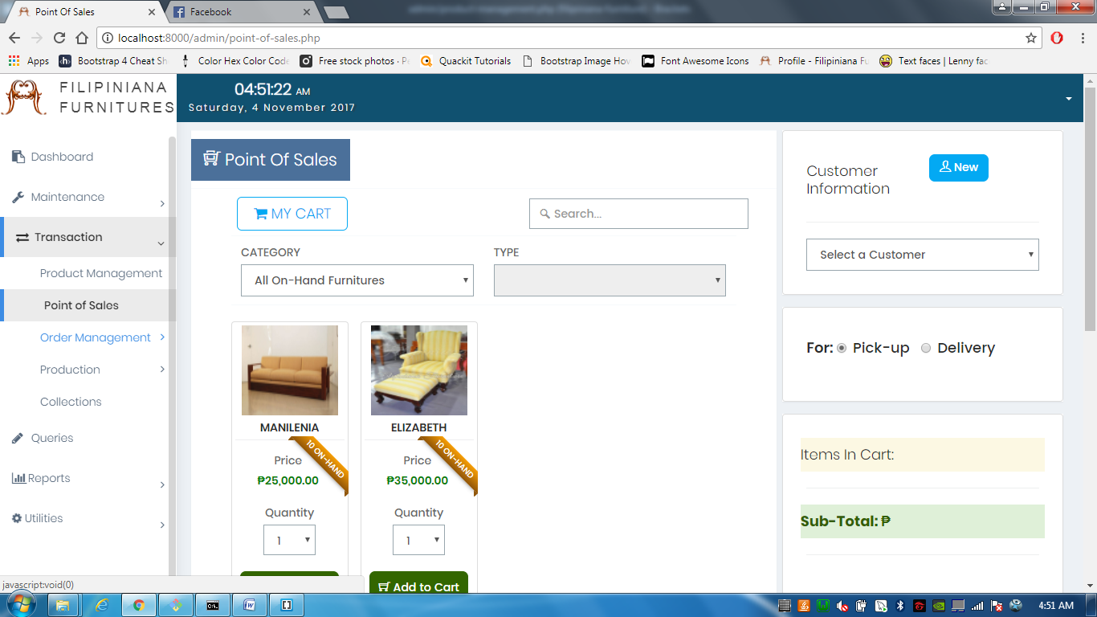

**Point of Sales** is where you can order the on hand products. This is supposedly for walk-in customers, the reason it is in the admin side of the system.

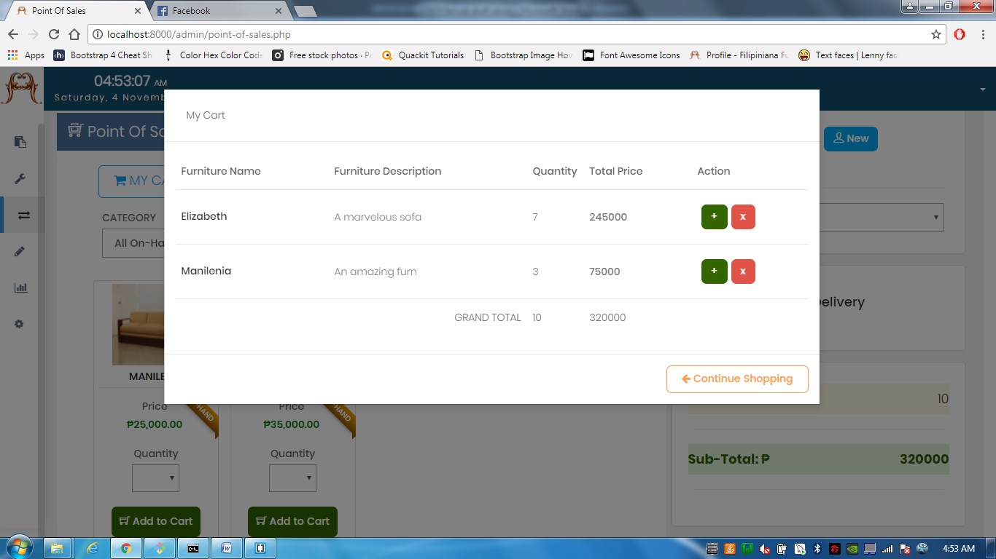

In **Point of Sales**, if you click **Add To Cart** after specifying the desired quantity, it will be added to your cart. In the **cart** (image above), you can add and deduct products.

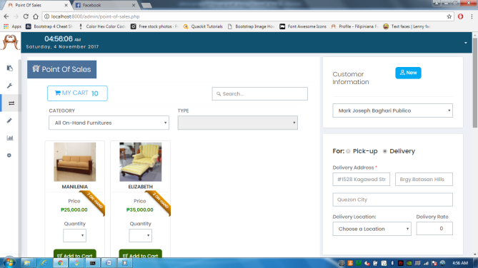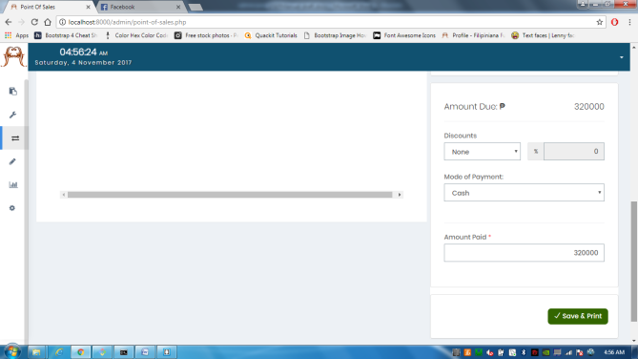

The form in the right side of the page, is the required data to be filled up by the customer. This includes basic information of the customer, delivery address or pick up date, down payment amount. Clicking **save & print** will view your initial receipt in .pdf format.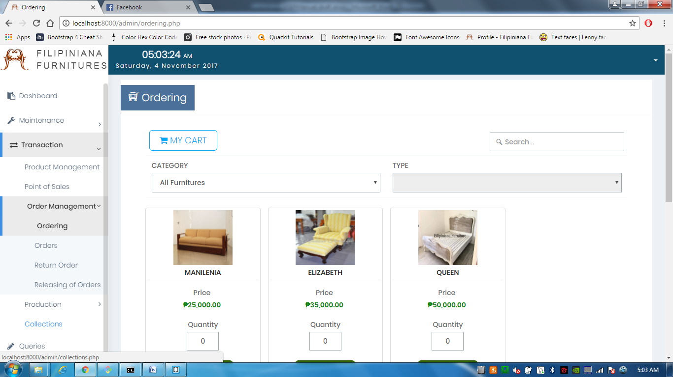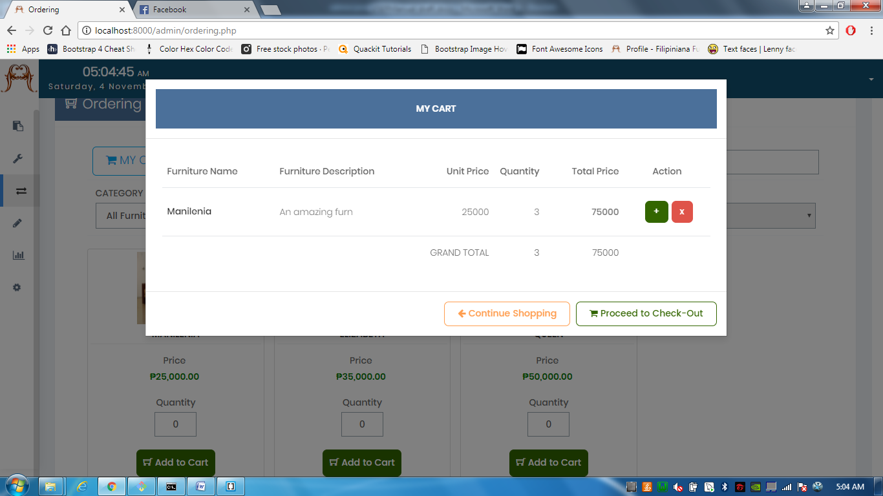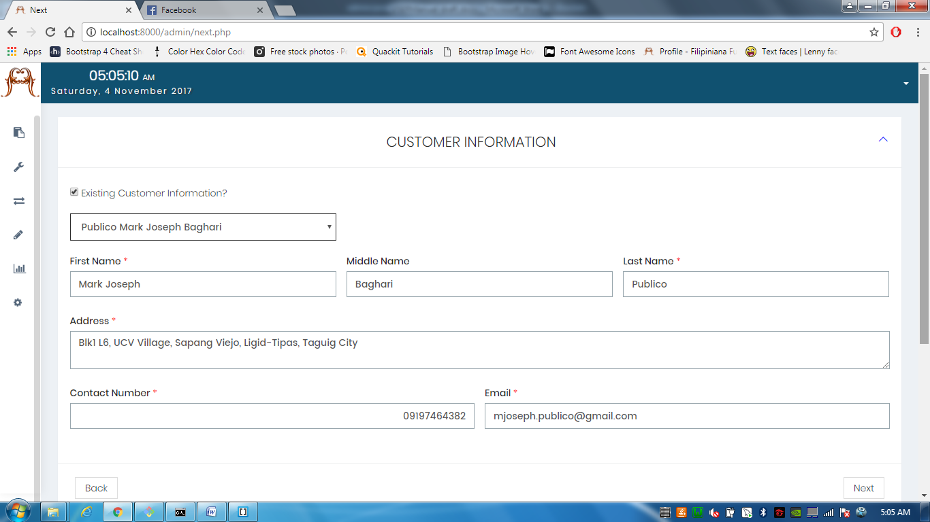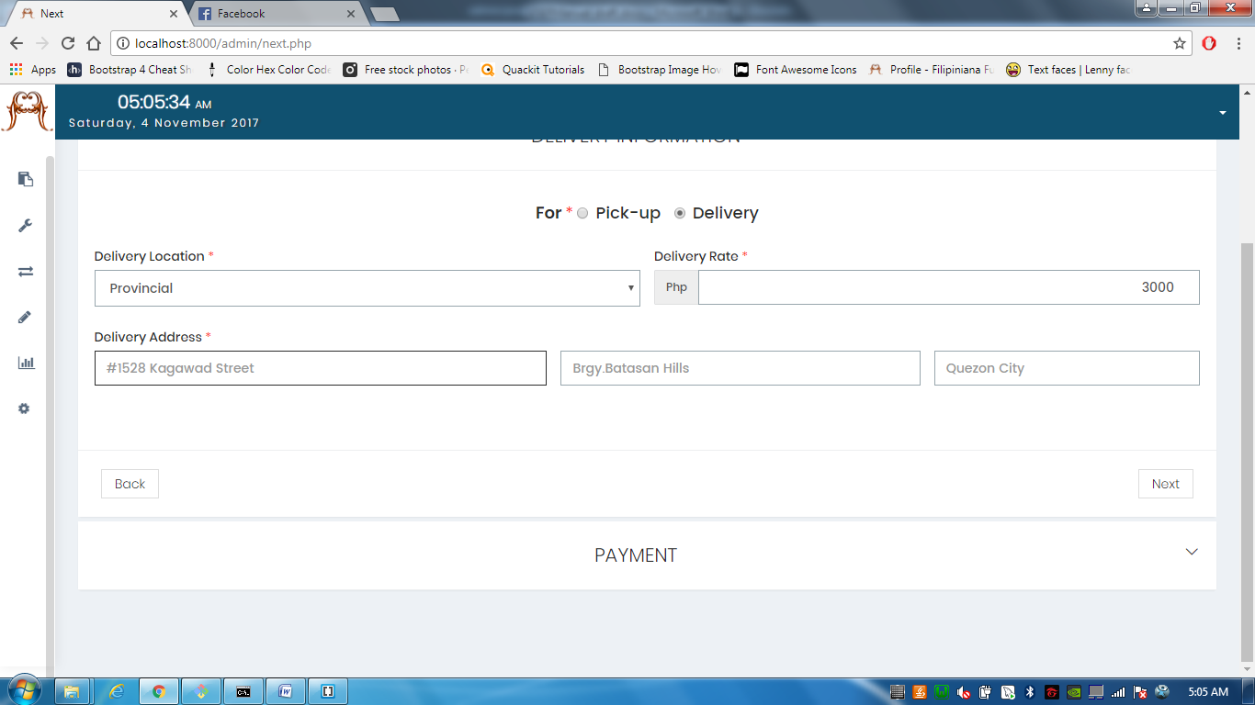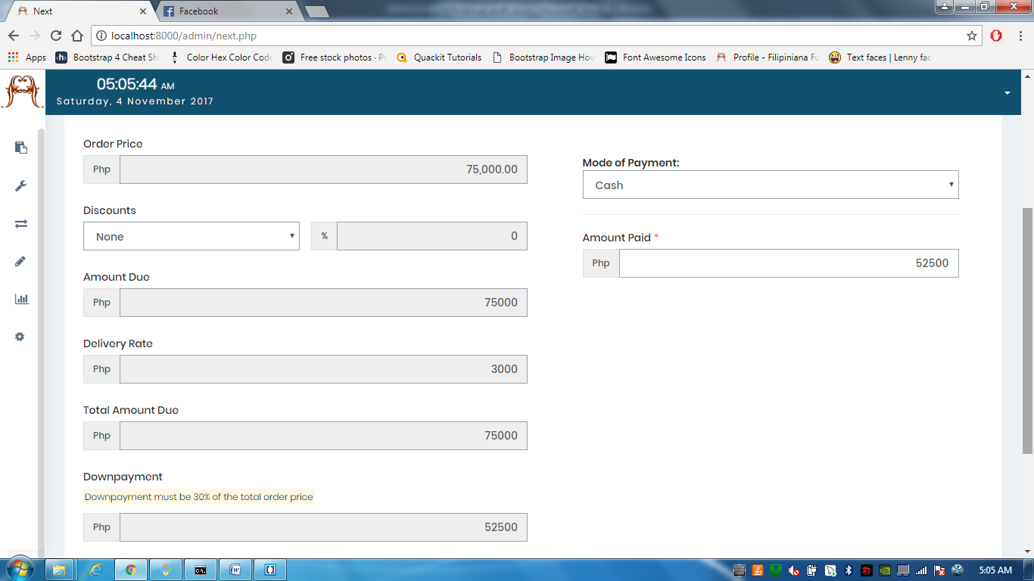

Under **Order Management,** first is **Ordering,** which allows you to order Pre-Order furnitures. This is similar in ordering on-hand products; with cart and checkout.

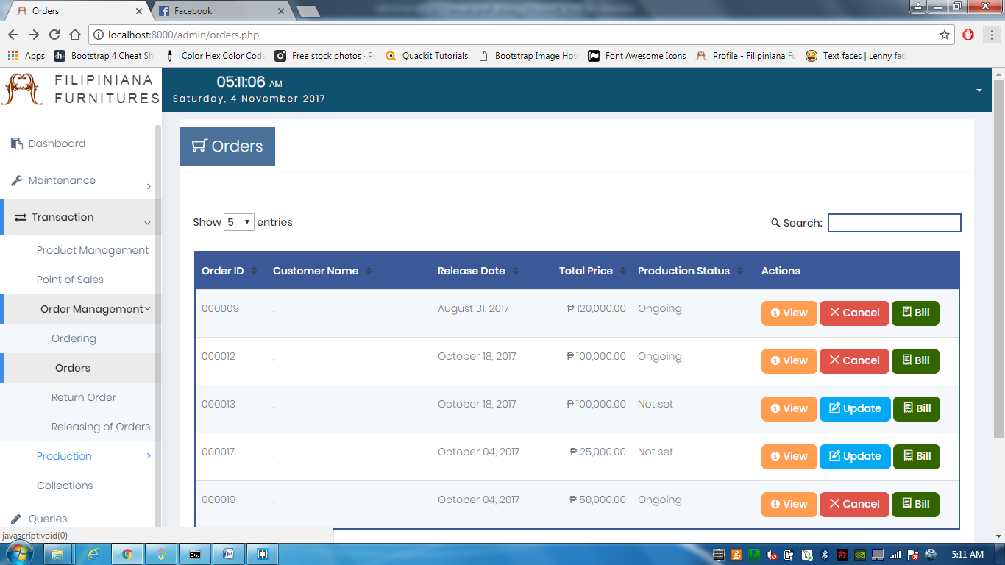

**Orders** is a list of orders that is either ongoing production or pending production.

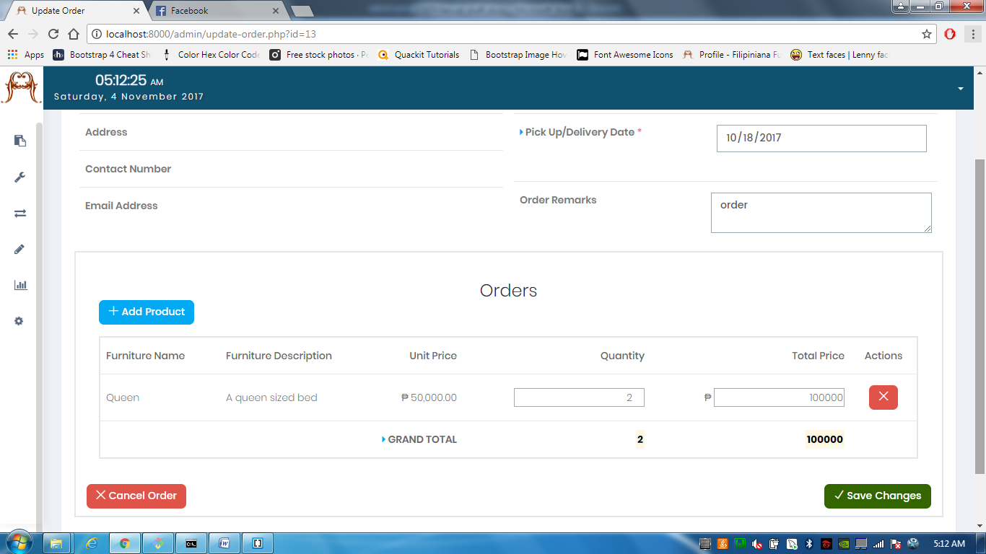

**Update** lets you edit the products of an order.

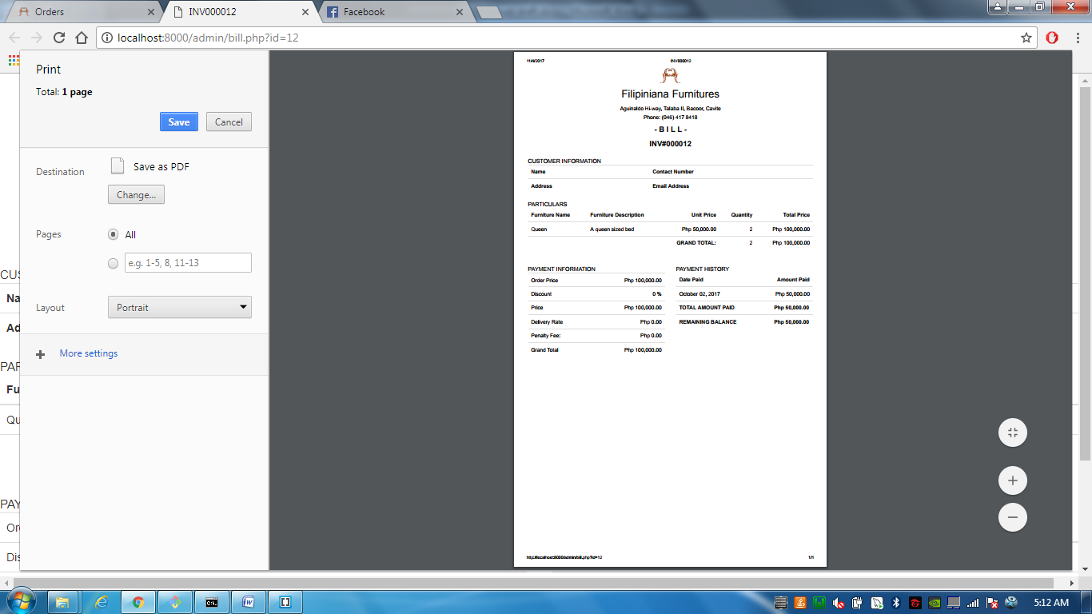

And **Bill** lets you bill the customer for his/her remaining balance.

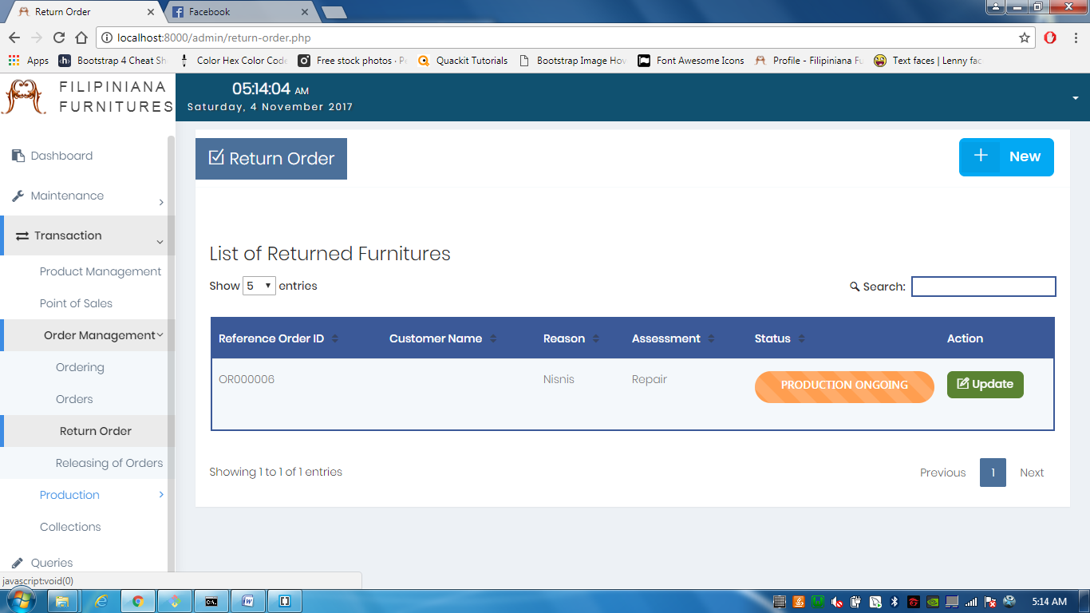

**Return Orders** lets you see the furnitures returned for repair or replace.

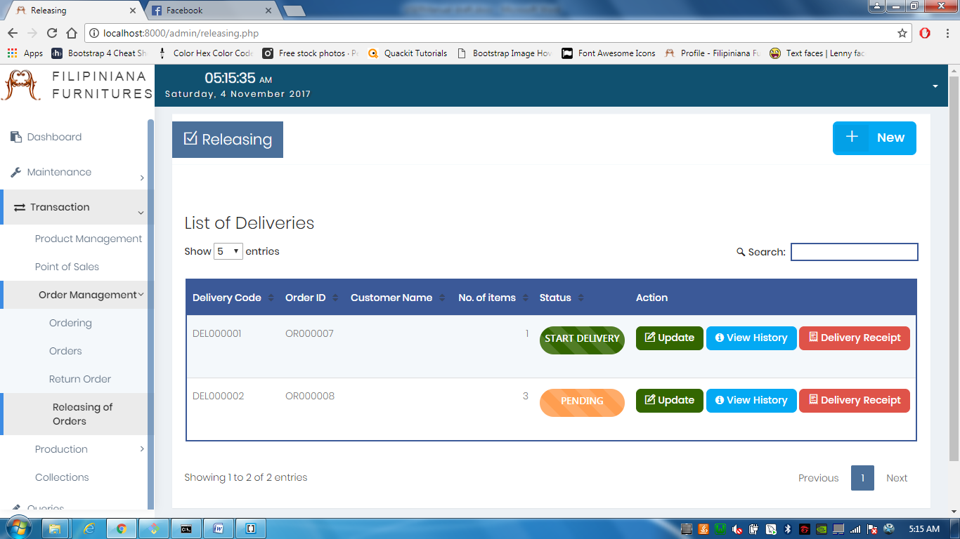

**Releasing** lets you see the furnitures that are finished and/or ready to be delivered. 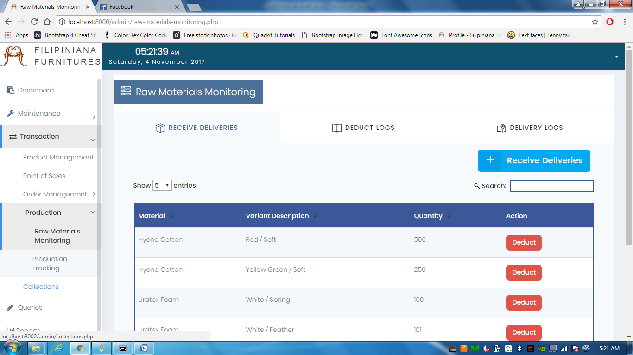

Under Production is **Raw Materials Monitoring,** the first tab is **Receive Deliveries** which allows you to see the materials delivered by the supplier discussed earlier. **Deduct Logs** is similar to a notification where actions are recorded. **Delivery Logs** is a list of the deliveries with respective suppliers.

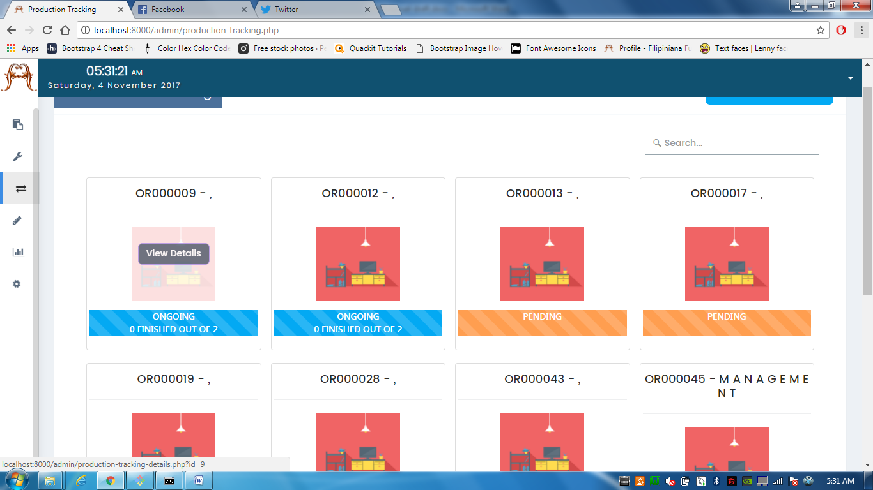

**Production Tracking**  lets you see the progress of orders undergoing production. **0 FINISHED OUT OF 2** means that in an order of 2 furnitures, nothing is finished yet. **Pending** means that the order's furnitures are not yet under production. If you hover each thumbnail, a button saying "View Details" will appear.

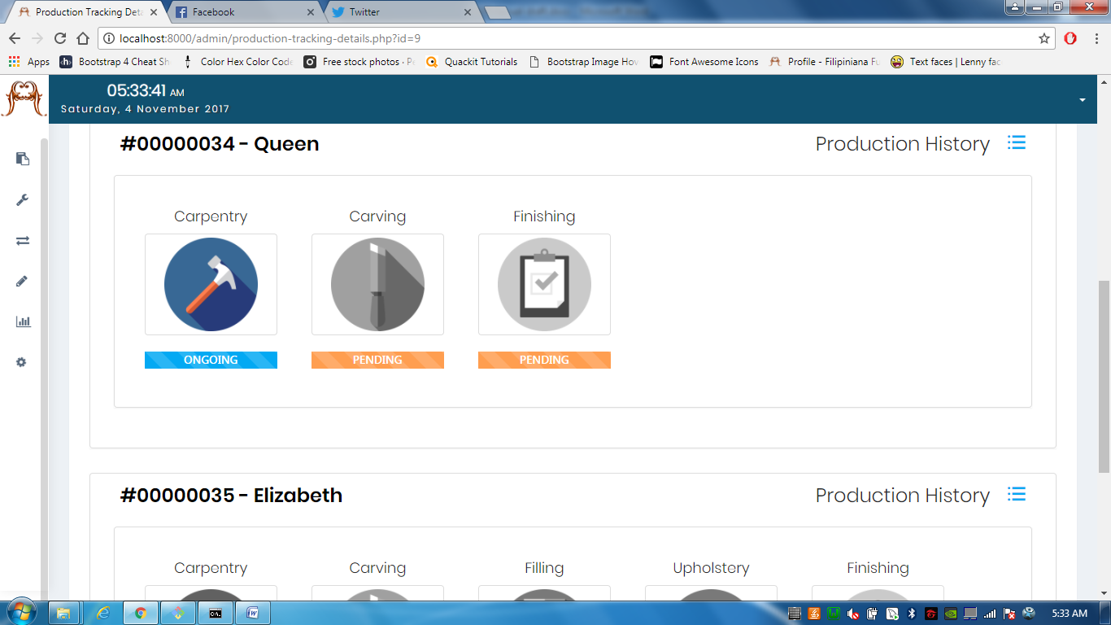

Clicking **View Details** directs you in this page. Every furniture has its own set of production phases. Overlaying the thumbnails gives you the options to start a production phase.

Remember that the phases are in order, for instance, you cannot start Finishing unless you finish Carpentry first, then Carving.

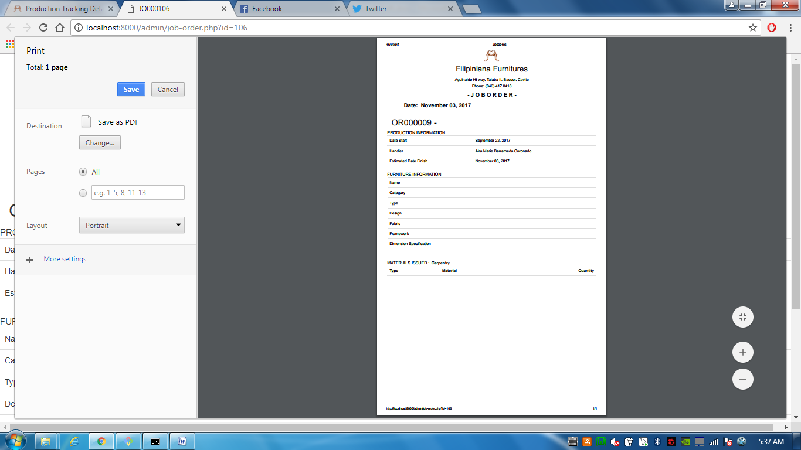

**Job Ticket** are the printable job order to be sent to the manufacturer. It contains the materials to be used, delegated employee, and the furniture information.

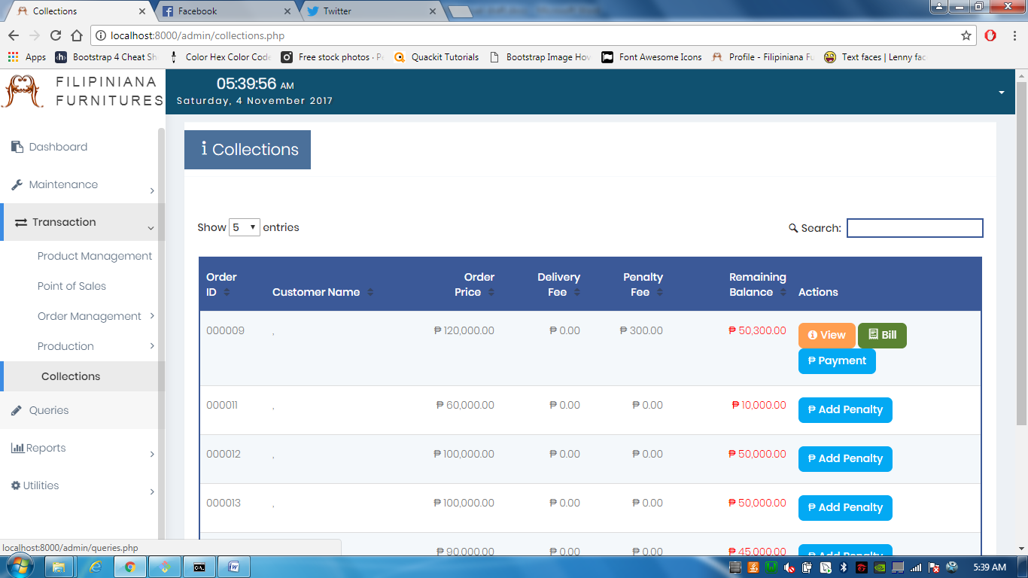

Lastly, the **Collections**  lets you see the orders with remaining balance. You can add penalty orders and Bill them again including the penalty fee.

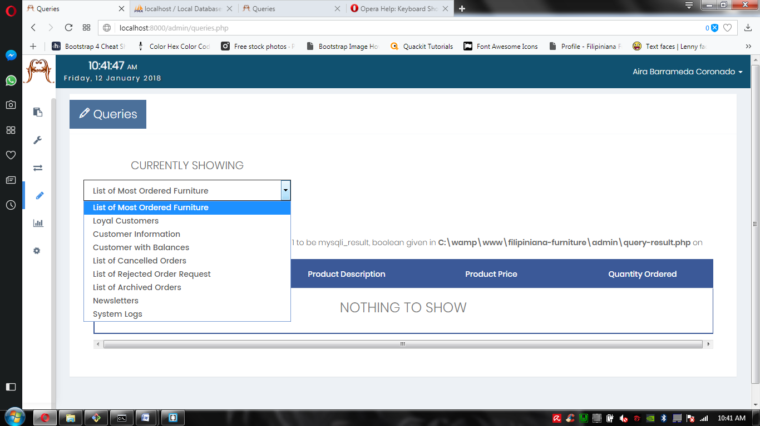2.3.5 | Queries

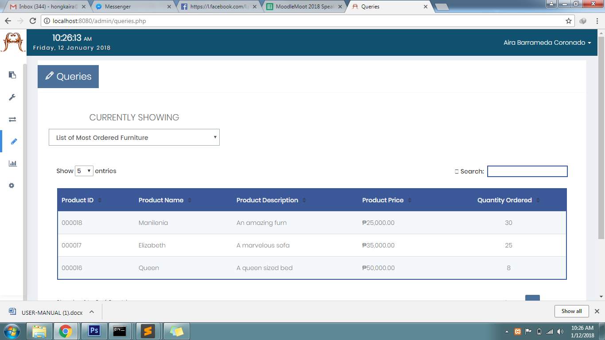The **Queries** the statistical facts for mainly minimal aspects of the business, this is for the purpose of reference. You may grant the most loyal customer an incentive, or maybe putting the most ordered furniture on sale.

2.3.6 | Reports

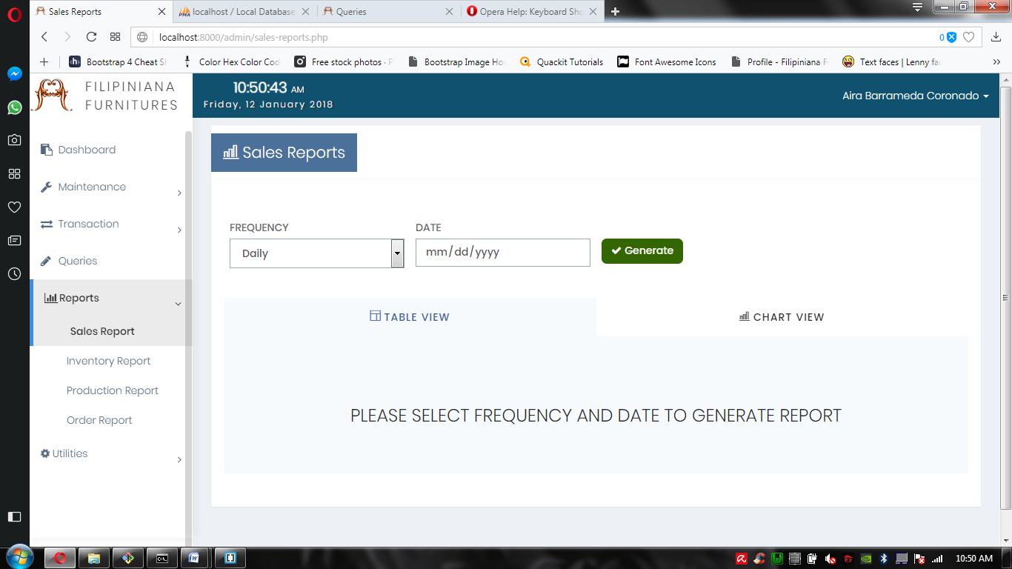Under the **Reports**, is the Sales Report, Inventory Report, Production Report, and Order Report.

The **Frequency** option dictates which data is to be shown, **Date** is the option to specify which daily data is to be shown. there are other options like **monthly**, to which you specify the month and year, and **annually**, to which you specify the year.

2.3.7 | Utilities

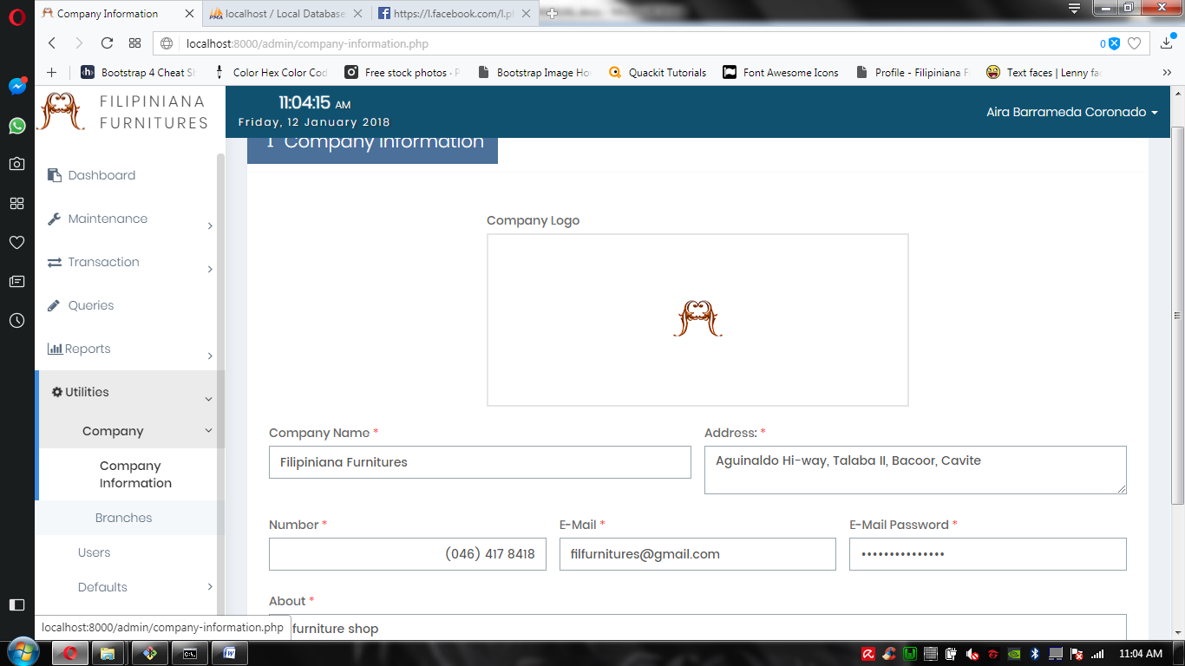

The first tab in utilities is the **Company**, under it is the **Company Information** where the basic information about the company lies. Here you can change the Company logo, name, address, contact number, email and its password, and a brief description about the company.

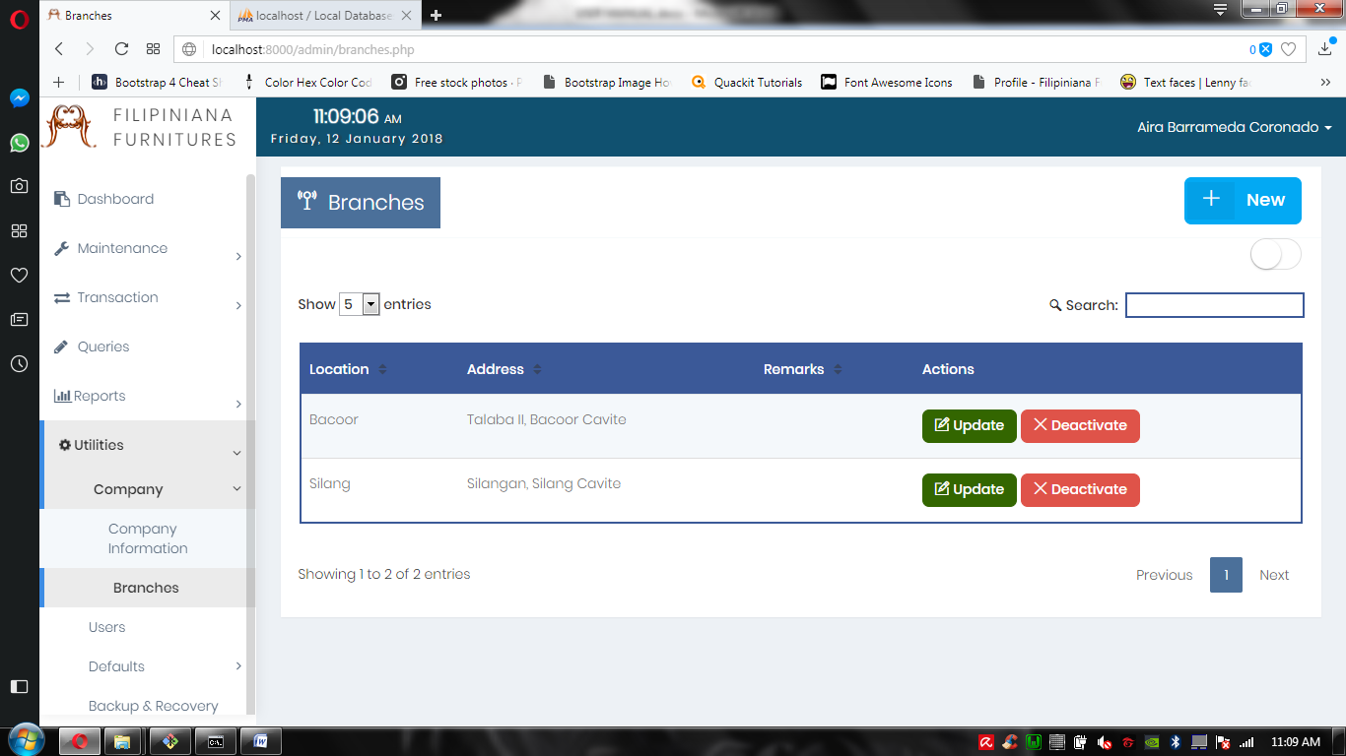

After Company Information, is its **branches** where you add a branch location whenever the company expands. You can also deactivate if the branch store closed down.

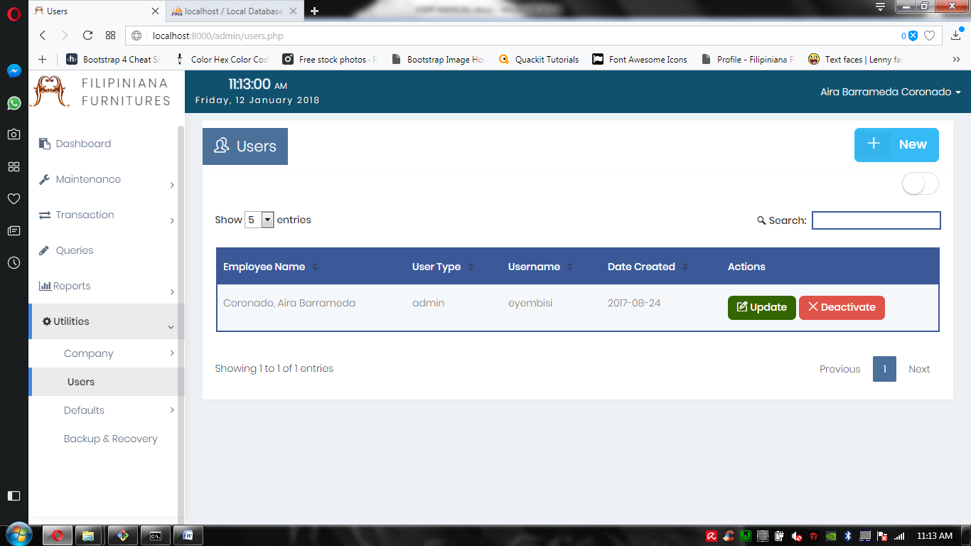

The second tab in the utilities is the **Users** tab, which shows you the users of the system, including employees, admin, and the staff accounts.

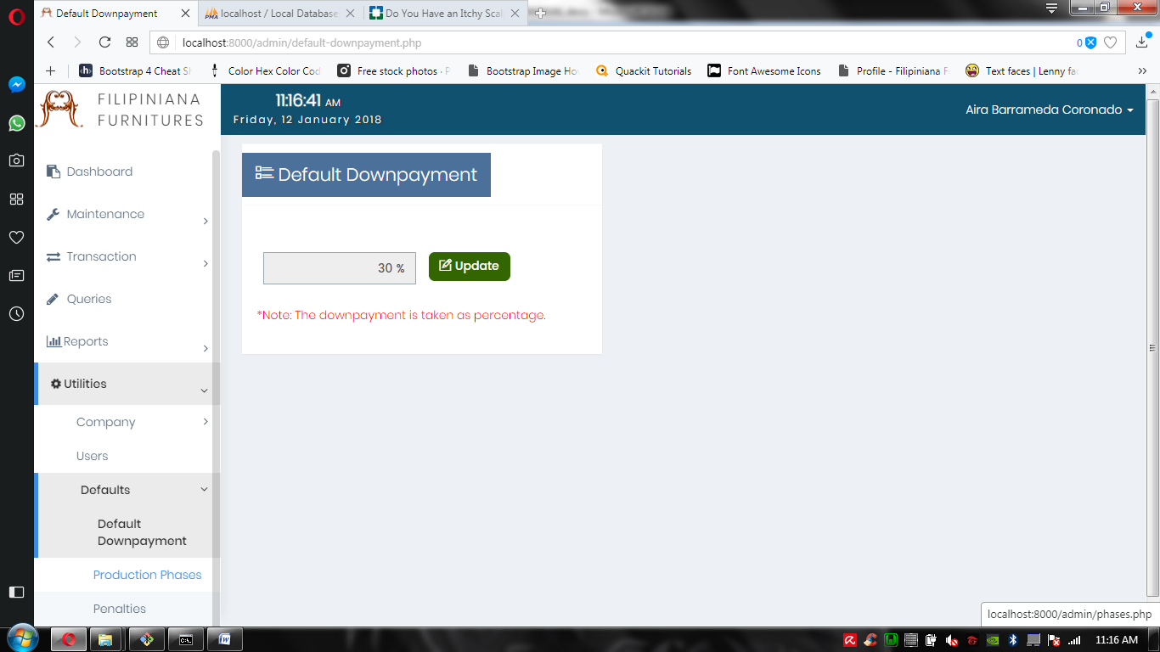

The third tab in the utilities section is the **Defaults** tab, in which you set the defaults in the system. First is the default down payment, where you just update its default.

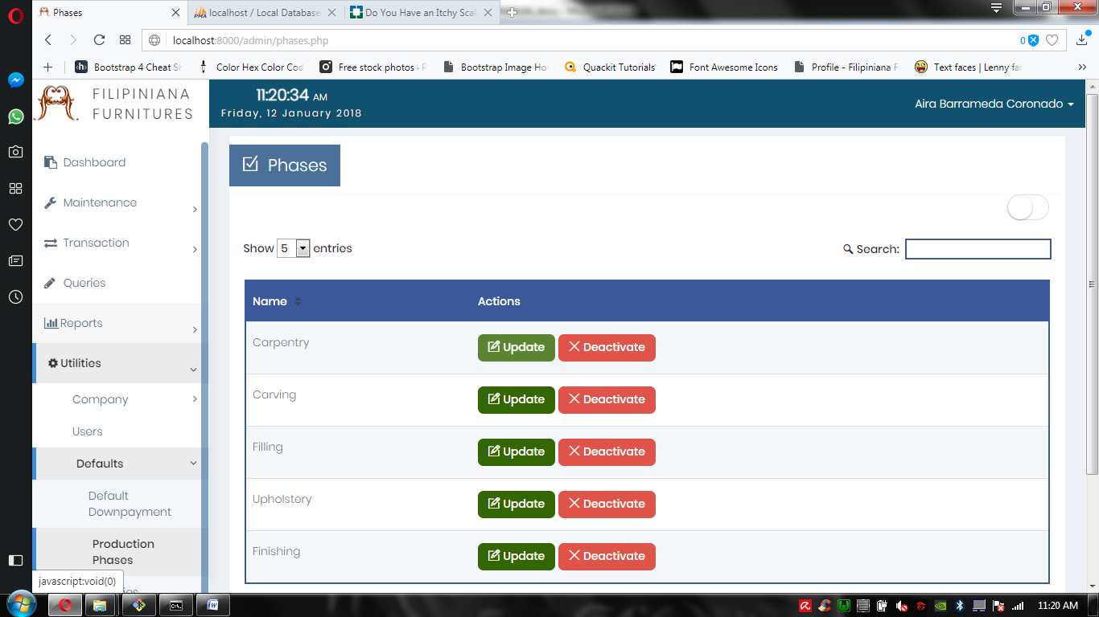

New is the default **production phases**, in case the company suddenly stopped doing fabricated furnitures, or suddenly stopped carving the frames. This would be a handy tool to get through those scenarios.

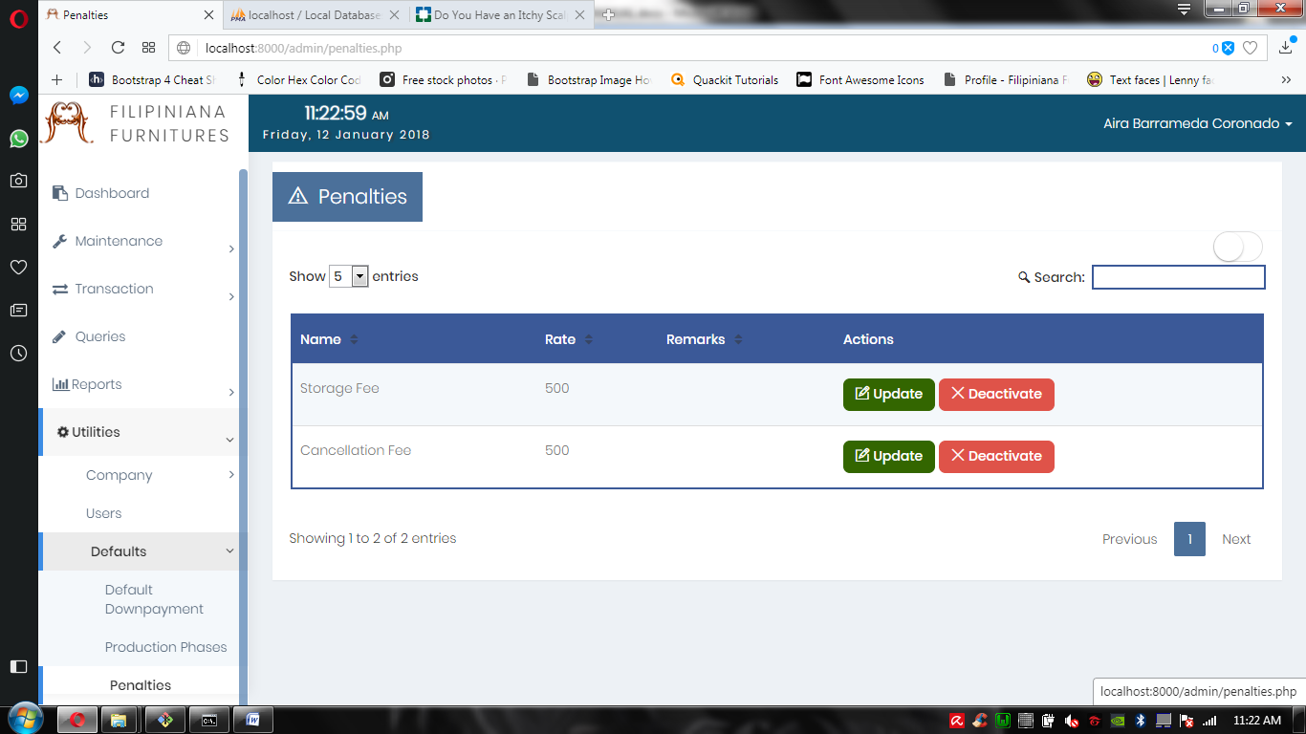

Lastly is the **Penalties**, in which you update the existing rates of the penalties such as the storage and cancellation fees. You can also deactivate those penalties.